Lista napędów DC - 2006

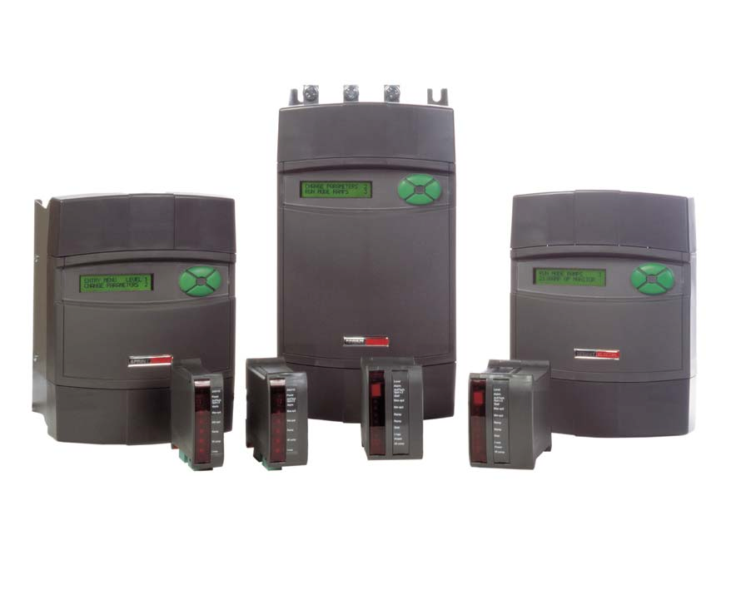

www.sprint-electric.com
- Data – Product manuals – Technical help – Drive glossary – FAQ – Brochures – Images – Data – Product manuals

DOC# HB102953 Iss 11 E&OE
Strona 2

zawartość

Jedno fazowy 1Q Nie izolowany DC regulator Strona 3

Jedno fazowy 1Q Izolowany DC regulator Strona 4

Jedno fazowy 4Q Ze zwrotem energii DC regulator Strona 6

Regulator for niskonapięciowy motors 24/48Vdc Strona 8

PL Trójfazowy 2Q Cyfrowy DC regulator Strona 9

PLX Trójfazowy 4Q Cyfrowy DC regulator Strona 12

PL/PLX Options & Accessories Strona 15

PLA Applications module Strona 15

PLXD stack driver Strona 15

SLE Trójfazowy 2Q Analogowy DC regulator Strona 15

SL Trójfazowy 2Q Analogowy DC regulator Strona 16

SLX Trójfazowy 4Q Analogowy DC regulator Strona 18

Niskonapięciowy Regulator Strona 20

Drive Enclosures 0.37Kw – 11Kw Strona 21

Cyfrowy Panel Meters Strona 21

Ancillary products Strona 21
Buffer Card Reversing unit Winder card
Frequency to Voltage converter Setpoint potentiometer kit Dynamic Brake assembly

Visit www.sprint-electric.com for further information or product technical manual for full specification.
Strona 3

Jedno fazowy 1Q DC Regulator - Nie izolowany

340 0.55KW 3.4A 240/110Vac 1Q Nie izolowany
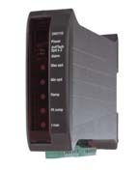

Controller Part # 340
30/60V AC supply input option
Semiconductor Fuse 6 x 32 Part # CH00620A Fuseholder 6 x 32 Part # CP102071
DIN Rail Clip for fuseholder Part # FE101969
Pot kit incl graduated dial & knob Part # POTKIT Filter (if required) Part # FRLN16

680 0.75KW 6.8A 240/110Vac 1Q Nie izolowany
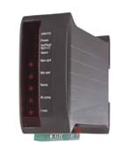

Controller Part # 680
30/60V AC supply input option
Semiconductor Fuse 6 x 32 Part # CH00620A Fuseholder 6 x 32 Part # CP102071
DIN Rail Clip for fuseholder Part # FE101969
Pot kit incl graduated dial & knob Part # POTKIT Filter (if required) Part # FRLN16

1220 1.8KW 12.2A 240/110Vac 1Q Nie izolowany

Controller Part # 1220
30/60V AC supply input option
Semiconductor Fuse 6 x 32 Part # CH00620A Fuseholder 6 x 32 Part # CP102071
DIN Rail Clip for fuseholder Part # FE101969
Pot kit incl graduated dial & knob Part # POTKIT Filter (if required) Part # FRLN16

300 0.37KW 3A 240/110Vac 1Q Nie izolowany
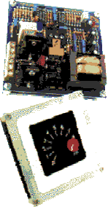

Controller Part # 300
30/60V AC supply input option
Semiconductor Fuse 6 x 32 Part # CH00608A Fuseholder 6 x 32 Part # CP102071
DIN Rail Clip for fuseholder Part # FE101969
Filter (if required) Part # FRLN16

370 0.55KW 3.7A 240/110Vac 1Q Nie izolowany
Controller Part # 370
30/60V AC supply input option
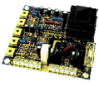

Semiconductor Fuse 6 x 32 Part # CH00608A Fuseholder 6 x 32 Part # CP102071
DIN Rail Clip for fuseholder Part # FE101969
Pot kit incl graduated dial & knob Part # POTKIT Filter (if required) Part # FRLN16

400 0.55KW 4A 240/110Vac 1Q Nie izolowany
Controller Part # 400
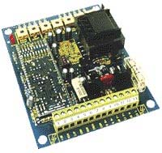

30/60V AC supply input option
Semiconductor Fuse 6 x 32 Part # CH00608A Fuseholder 6 x 32 Part # CP102071
DIN Rail Clip for fuseholder Part # FE101969
Pot kit incl graduated dial & knob Part # POTKIT

Please refer to catalogue for further information or product technical manual for full specification.
Strona 4

Filter (if required) Part # FRLN16

800 1.1KW 8A 240/110Vac 1Q Nie izolowany
Controller Part # 800
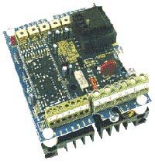

30/60V AC supply input option
Semiconductor Fuse 6 x 32 Part # CH00612A Fuseholder 6 x 32 Part # CP102071
DIN Rail Clip for fuseholder Part # FE101969
Pot kit incl graduated dial & knob Part # POTKIT Filter (if required) Part # FRLN16

1200 1.8KW 12A 240/110Vac 1Q Nie izolowany
Controller Part # 1200

30/60V AC supply input option
Semiconductor Fuse 6 x 32 Part # CH00620A Fuseholder 6 x 32 Part # CP102071
DIN Rail Clip for fuseholder Part # FE101969
Pot kit incl graduated dial & knob Part # POTKIT Filter (if required) Part # FRLN16
KW ratings shown are at highest supply voltage.

Jedno fazowy 1Q DC Regulator - Izolowany

340i 0.55KW 3.4A 240/110Vac 1Q Izolowany
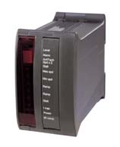

Controller Part # 340i
30/60V AC supply input option
Semiconductor Fuse 6 x 32 Part # CH00620A Fuseholder 6 x 32 Part # CP102071
DIN Rail Clip for fuseholder Part # FE101969
Pot kit incl graduated dial & knob Part # POTKIT Filter (if required) Part # FRLN16

680i 0.75KW 6.8A 240/110Vac 1Q Izolowany
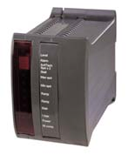

Controller Part # 680i
30/60V AC supply input option
Semiconductor Fuse 6 x 32 Part # CH00620A Fuseholder 6 x 32 Part # CP102071
DIN Rail Clip for fuseholder Part # FE101969
Pot kit incl graduated dial & knob Part # POTKIT Filter (if required) Part # FRLN16

1220i 1.8KW 12.2A 240/110Vac 1Q Izolowany
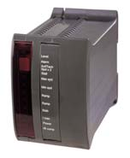

Controller Part # 1220i
30/60V AC supply input option
Semiconductor Fuse 6 x 32 Part # CH00620A Fuseholder 6 x 32 Part # CP102071
DIN Rail Clip for fuseholder Part # FE101969
Pot kit incl graduated dial & knob Part # POTKIT Filter (if required) Part # FRLN16

Visit www.sprint-electric.com for further information or product technical manual for full specification.
Strona 5

400i 0.55KW 4A 240/110Vac 1Q Izolowany
Controller Part # 400i
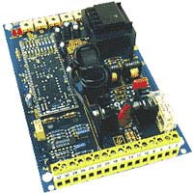

30/60V AC supply input option
Semiconductor Fuse 6 x 32 Part # CH00608A Fuseholder 6 x 32 Part # CP102071
DIN Rail Clip for fuseholder Part # FE101969
Pot kit incl graduated dial & knob Part # POTKIT Filter (if required) Part # FRLN16

E400i 0.55KW 4A 240/110Vac 1Q Izolowany
Controller Part # E400i
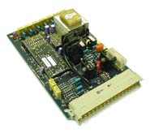

30/60V AC supply input option
Semiconductor Fuse 6 x 32 Part # CH00608A Fuseholder 6 x 32 Part # CP102071
DIN Rail Clip for fuseholder Part # FE101969
Pot kit incl graduated dial & knob Part # POTKIT Filter (if required) Part # FRLN16

1600i 2.2KW 16A 240/110Vac 1Q Izolowany
Controller Part # 1600i
30/60V AC supply input option
Semiconductor Fuse 14 x 51 Part # CH00730A Fuseholder 14 x 51 Part # CP102053
Pot kit incl graduated dial & knob Part # POTKIT Filter (if required) Part # FRLN16
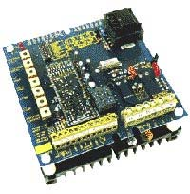

3200i/8 2.2KW 8A 415/240Vac 1Q Izolowany
Controller Part # 3200i/8
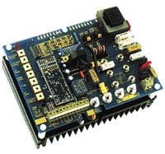

30/60V AC supply input option
Semiconductor Fuse 6 x 32 Part # CH00612A Fuseholder 6 x 32 Part # CP102071
DIN Rail Clip for fuseholder Part # FE101969
Pot kit incl graduated dial & knob Part # POTKIT Filter (240V operation, if required) Part # FRLN16
Filter (415V operation, if required) Part # FRLL16
Note. Two fuses & holders etc. required for 415V Line to Line operation.

3200i/16 4KW 16A 415/240Vac 1Q Izolowany
Controller Part # 3200i/16

30/60V AC supply input option
Semiconductor Fuse 14 x 51 Part # CH00730A Fuseholder 14 x 51 Part # CP102053
Pot kit incl graduated dial & knob Part # POTKIT Filter (240V operation, if required) Part # FRLN16
Filter (415V operation, if required) Part # FRLL16
Note. Two fuses & holders required for 415V Line to Line operation.

3200i/32 7.5KW 32A 415/240Vac 1Q Izolowany
Controller Part # 3200i/32

30/60V AC supply input option
Semiconductor Fuse Size OOO Part # CH00850A Fuseholder Size OOO Part # CP102054
Pot kit incl graduated dial & knob Part # POTKIT Filter (if required) Part # FRLL36

Please refer to catalogue for further information or product technical manual for full specification.
Strona 6

Note. Two fuses & holders required for 415V Line to Line operation.

3200i/48 11KW 48A 415/240Vac 1Q Izolowany
Controller Part # 3200i/48
30/60V AC supply input option
Semiconductor Fuse Size OOO Part # CH00880A Fuseholder Size OOO Part # CP102054
Pot kit incl graduated dial & knob Part # POTKIT Filter (if required) Part # FRLL50
Note. Two fuses & holders required for 415V Line to Line operation.

Jedno fazowy 4Q DC Regulator - Izolowany, Ze zwrotem energii

340XRi 0.55KW 3.4A 240/110Vac 4Q Regen Izolowany
Controller Part # 340XRi

30/60V AC supply input option
Semiconductor Fuse 6 x 32 Part # CH00620A Fuseholder 6 x 32 Part # CP102071
DIN Rail Clip for fuseholder Part # FE101969
Pot kit incl graduated dial & knob Part # POTKIT Filter (if required) Part # FRLN16

680XRi 0.75KW 6.8A 240/110Vac 4Q Regen Izolowany
Controller Part # 680XRi
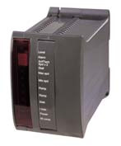

30/60V AC supply input option
Semiconductor Fuse 6 x 32 Part # CH00620A Fuseholder 6 x 32 Part # CP102071
DIN Rail Clip for fuseholder Part # FE101969
Pot kit incl graduated dial & knob Part # POTKIT Filter (if required) Part # FRLN16

1220XRi 1.8KW 12.2A 240/110Vac 4Q Regen Izolowany
Controller Part # 1220XRi

30/60V AC supply input option
Semiconductor Fuse 6 x 32 Part # CH00620A Fuseholder 6 x 32 Part # CP102071
DIN Rail Clip for fuseholder Part # FE101969
Pot kit incl graduated dial & knob Part # POTKIT Filter (if required) Part # FRLN16

Visit www.sprint-electric.com for further information or product technical manual for full specification.
Strona 7

3600XRi/4 0.55KW 4A 240/110Vac 4Q Izolowany
Controller Part # 3600XRi/4/LN
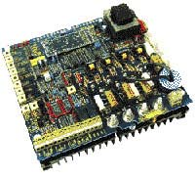

30/60V AC supply input option
Filter Part # FRLN16
Semiconductor Fuse 6 x 32 Part # CH00608A Fuseholder 6 x 32 Part # CP102071
DIN Rail Clip for fuseholder Part # FE101969
Pot kit incl graduated dial & knob Part # POTKIT

3600XRi/8 1.1KW 8A 240/110Vac 4Q Izolowany
Controller Part # 3600XRi/8/LN

30/60V AC supply input option
Filter Part # FRLN16
Semiconductor Fuse 6 x 32 Part # CH00620A Fuseholder 6 x 32 Part # CP102071
DIN Rail Clip for fuseholder Part # FE101969
Pot kit incl graduated dial & knob Part # POTKIT

3600XRi/16 2.2KW 16A 240/110Vac 4Q Izolowany

Controller Part # 3600XRi/16/LN
30/60V AC supply input option
Filter Part # FRLN16
Semiconductor Fuse 14 x 51 Part # CH00730A Fuseholder 14 x 51 Part # CP102053
Pot kit incl graduated dial & knob Part # POTKIT

3600XRi/16 4KW 16A 415/240Vac 4Q Izolowany

Controller Part # 3600XRi/16/LL
30/60V AC supply input option
Filter Part # FRLL16
Semiconductor Fuse 14 x 51 Part # CH00730A Fuseholder 14 x 51 Part # CP102053
Pot kit incl graduated dial & knob Part # POTKIT
Note. Two fuses & holders required for 415V Line to Line operation.
3600XRi/32 7.5KW 32A 415/240Vac 4Q Izolowany
Controller Part # 3600XRi/32/LL

30/60V AC supply input option
Filter Part # FRLL36
Semiconductor Fuse Size OOO Part # CH00850A Fuseholder Size OOO Part # CP102054
Pot kit incl graduated dial & knob Part # POTKIT
Note. Two fuses & holders required for 415V Line to Line operation.

3600XRi/36 9.5KW 36A 415/240Vac 4Q Izolowany
Controller Part # 3600XRi/36/LL

30/60V AC supply input option
Filter Part # FRLL36
Semiconductor Fuse Size OOO Part # CH00850A Fuseholder Size OOO Part # CP102054
Pot kit incl graduated dial & knob Part # POTKIT
Note. Two fuses & holders required for 415V Line to Line operation.

KW ratings shown are at high supply voltage.

Please refer to catalogue for further information or product technical manual for full specification.
Strona 8

Niskonapięciowy 24/48 Vdc

Niskonapięciowy versions of all single-phase models. Suitable for 30/60V
ac input voltages; these regulator are ideal for motors with armature voltages of 24/48v d.c.

340 LV60 3.4 Amps nie izolowany

680 LV60 6.8 Amps nie izolowany

1220 LV60 12.2 Amps nie izolowany

340i LV60 3.4 Amps Izolowany

680i LV60 6.8 Amps Izolowany

1220i LV60 12.2 Amps Izolowany

340XRi LV60 3.4 Amps Izolowany 4Q Regen

680XRi LV60 6.8 Amps Izolowany 4Q Regen

1220XRi LV60 12.2 Amps Izolowany 4Q Regen

370LV60 3.7Amps nie izolowany

400LV60 4 Amps nie izolowany

400ILV60 4 Amps, izolowany

E400iLV60 4 Amps, izolowany, Eurocard.

800LV60 8 Amps nie izolowany

1200LV60 12 Amps nie izolowany

1600iLV60 16 Amps, izolowany

3200i/32/LV60 32 Amps, izolowany

3200i/48/LV60 48 Amps, izolowany

3600XRi/4/LV60 4 Amps, izolowany, 4Q regen

3600XRi/8/LV60 8 Amps, izolowany, 4Q regen

3600XRi/16/LV60 16 Amps, izolowany, 4Q regen

3600XRi/32/LV60 32 Amps, izolowany, 4Q regen

3600XRi/36/LV60 36 Amps, izolowany, 4Q regen

Visit www.sprint-electric.com for further information or product technical manual for full specification.
Strona 9

PL range, Cyfrowy Trójfazowy 2Q drive with integral field weakener

PL5 5KW 12A. This model has ze zwrotem energii stopping capability as standard
Controller Part # PL5
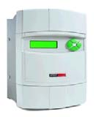

Line reactor Part # LR48
Aux semiconductor Fuse, 3 required 6 x 32 Part # CH00620A Aux Fuseholder, 3 required 6 x 32 Part # CP102071
Main semiconductor Fuse, 3 required 6 x 32 Part # CH00612A Fuseholder, 3 required 6 x 32 Part # CP102071
DIN Rail Clip for holder,6 required Part # FE101969
Pot kit incl graduated dial & knob Part # POTKIT

PL10 10KW 24A. This model has ze zwrotem energii stopping capability as standard
Controller Part # PL10
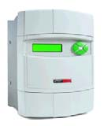

Line reactor Part # LR48
Aux semiconductor Fuse, 3 required 6 x 32 Part # CH00620A Aux Fuseholder, 3 required 6 x 32 Part # CP102071
DIN Rail Clip for aux fuseholder,3 required Part # FE101969
Main semiconductor Fuse, 3 required 14 x 51 Part # CH00740A Main Fuseholder, 3 required 14 x 51 Part # CP102053
Pot kit incl graduated dial & knob Part # POTKIT

PL15 15KW 36A. This model has ze zwrotem energii stopping capability as standard
Controller Part # PL15

Line reactor Part # LR48
Aux semiconductor Fuse, 3 required 6 x 32 Part # CH00620A Aux Fuseholder, 3 required 6 x 32 Part # CP102071
DIN Rail Clip for Aux fuseholder,3 required Part # FE101969
Main semiconductor Fuse, 3 required 14 x 51 Part # CH00740A Main Fuseholder, 3 required 14 x 51 Part # CP102053
Pot kit incl graduated dial & knob Part # POTKIT

PL20 20KW 51A. This model has ze zwrotem energii stopping capability as standard
Controller Part # PL20

Line reactor Part # LR48
Aux semiconductor Fuse, 3 required 6 x 32 Part # CH00620A Aux Fuseholder, 3 required 6 x 32 Part # CP102071
DIN Rail Clip for Aux fuseholder,3 required Part # FE101969
Main semiconductor Fuse, 3 required Size OOO Part # CH00850A Main Fuseholder, 3 required Size OOO Part # CP102054
Pot kit incl graduated dial & knob Part # POTKIT

PL30 30KW 72A. This model has ze zwrotem energii stopping capability as standard
Controller Part # PL30

Line reactor Part # LR120
Aux semiconductor Fuse, 3 required 6 x 32 Part # CH00620A Aux Fuseholder, 3 required 6 x 32 Part # CP102071
DIN Rail Clip for Aux fuseholder,3 required Part # FE101969
Main semiconductor Fuse, 3 required Size OOO Part # CH00880A Main Fuseholder, 3 required Size OOO Part # CP102054
Pot kit incl graduated dial & knob Part # POTKIT

Please refer to catalogue for further information or product technical manual for full specification.
Strona 10

PL40 40KW 99A. This model has ze zwrotem energii stopping capability as standard
Controller Part # PL40

Line reactor Part # LR120
Aux semiconductor Fuse, 3 required 6 x 32 Part # CH00620A Aux Fuseholder, 3 required 6 x 32 Part # CP102071
DIN Rail Clip for Aux fuseholder,3 required Part # FE101969
Main semiconductor Fuse, 3 required Size OOO Part # CH008100
Main Fuseholder, 3 required Size OOO Part # CP102054
Pot kit incl graduated dial & knob Part # POTKIT

PL50 50KW 123A. This model has ze zwrotem energii stopping capability as standard
Controller Part # PL50

Line reactor Part # LR120
Aux semiconductor Fuse, 3 required 6 x 32 Part # CH00620A Aux Fuseholder, 3 required 6 x 32 Part # CP102071
DIN Rail Clip for Aux fuseholder,3 required Part # FE101969
Main semiconductor Fuse, 3 required Size OOO Part # CH008125
Main Fuseholder, 3 required Size OOO Part # CP102054
Pot kit incl graduated dial & knob Part # POTKIT

PL65 65KW 155A
Controller Part # PL65
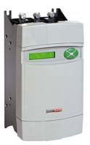

Line reactor Part # LR270
Main semiconductor Fuse, 3 required Size OOO Part # CH008160
Main Fuseholder, 3 required Size OOO Part # CP102054
Aux semiconductor Fuse, 3 required 6 x 32 Part # CH00620A Aux Fuseholder, 3 required 6 x 32 Part # CP102071
DIN Rail Clip for Aux- fuseholder, 3 required. Part # FE101969
Pot kit incl graduated dial & knob Part # POTKIT

PL85 85KW 205A
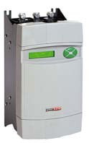

Controller Part # PL85
Line reactor Part # LR270
Main semiconductor Fuse, 3 required Size 1 Part # CH009250
Main 3 pole Fuseholder Size 1 Part # CP102055
Aux semiconductor Fuse, 3 required 6 x 32 Part # CH00620A Aux Fuseholder, 3 required 6 x 32 Part # CP102071
DIN Rail Clip for Aux- fuseholder, 3 required. Part # FE101969
Pot kit incl graduated dial & knob Part # POTKIT

PL115 115KW 270A
Controller Part # PL115

Line reactor Part # LR270
Main semiconductor Fuse, 3 required Size 1 Part # CH009250
Main 3 pole Fuseholder Size 1 Part # CP102055
Aux semiconductor Fuse, 3 required 6 x 32 Part # CH00620A Aux Fuseholder, 3 required 6 x 32 Part # CP102071
DIN Rail Clip for Aux- fuseholder, 3 required. Part # FE101969
Pot kit incl graduated dial & knob Part # POTKIT

Visit www.sprint-electric.com for further information or product technical manual for full specification.
Strona 11

PL145 145KW 330A. This model has ze zwrotem energii stopping capability as standard
Controller Part # PL145

Line reactor Part # LR330
Main semiconductor Fuse, 3 required Size 3 Part # CH010550
Main 3 pole Fuseholder Size 3 Part # CP102233
Aux semiconductor Fuse, 3 required 6 x 32 Part # CH00620A Aux Fuseholder, 3 required 6 x 32 Part # CP102071
DIN Rail Clip for Aux- fuseholder, 3 required. Part # FE101969
Pot kit incl graduated dial & knob Part # POTKIT

PL185 185KW 430A
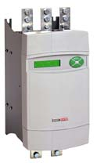

Controller Part # PL185
50 Amp option on field output
Line reactor Part # LR430
Main semiconductor Fuse, 3 required Size 3 Part # CH010550
Main 3 pole Fuseholder Size 3 Part # CP102233
Aux Semiconductor Fuse Size OOO, 3 required Part # CH00850A Aux Fuseholder Size OOO, 3 required Part # CP102054
Pot kit incl graduated dial & knob Part # POTKIT

PL225 225KW 530A. This model has ze zwrotem energii stopping capability as standard
Controller Part # PL225

50 Amp option on field output
Line reactor Part # LR530
Main semiconductor Fuse, 3 required Size 3 Part # CH010550
Main 3 pole Fuseholder Size 3 Part # CP102233
Aux Semiconductor Fuse Size OOO, 3 required Part # CH00850A Aux Fuseholder Size OOO, 3 required Part # CP102054
Pot kit incl graduated dial & knob Part # POTKIT

PL265 265KW 630A

Controller Part # PL265
50 Amp option on field output
Line reactor Part # LR630
Main semiconductor Fuse, 3 required Size 3 Part # CH010700
Main 3 pole Fuseholder Size 3 Part # CP102233
Aux Semiconductor Fuse Size OOO, 3 required Part # CH00850A Aux Fuseholder Size OOO, 3 required Part # CP102054
Pot kit incl graduated dial & knob Part # POTKIT

Please refer to catalogue for further information or product technical manual for full specification.
Strona 12

PLX range, Cyfrowy Trójfazowy 4Q fully ze zwrotem energii controller with
integral field weakener

PLX5 5KW 12A 4Q
Controller Part # PLX5

Line reactor Part # LR48
Aux semiconductor Fuse, 3 required 6 x 32 Part # CH00620A Aux Fuseholder, 3 required 6 x 32 Part # CP102071
Main semiconductor Fuse, 3 required 6 x 32 Part # CH00612A Fuseholder, 3 required 6 x 32 Part # CP102071
DIN Rail Clip for holder,6 required Part # FE101969
Armature fuse Part # CH00816A Armature fuseholder Part # CP102906
Pot kit incl graduated dial & knob Part # POTKIT

PLX10 10KW 24A 4Q
Controller Part # PLX10

Line reactor Part # LR48
Aux semiconductor Fuse, 3 required 6 x 32 Part # CH00620A Aux Fuseholder, 3 required 6 x 32 Part # CP102071
DIN Rail Clip for Aux fuseholder,3 required Part # FE101969
Main semiconductor Fuse, 3 required 14 x 51 Part # CH00740A Main Fuseholder, 3 required 14 x 51 Part # CP102053
Armature fuse Part # CH00832A Armature fuseholder Part # CP102906
Pot kit incl graduated dial & knob Part # POTKIT

PLX15 15KW 36A 4Q
Controller Part # PLX15

Line reactor Part # LR48
Aux semiconductor Fuse, 3 required 6 x 32 Part # CH00620A Aux Fuseholder, 3 required 6 x 32 Part # CP102071
DIN Rail Clip for Aux fuseholder,3 required Part # FE101969
Main semiconductor Fuse, 3 required 14 x 51 Part # CH00740A Main Fuseholder, 3 required 14 x 51 Part # CP102053
Armature fuse Part # CH00940A Armature fuseholder Part # CP102906
Pot kit incl graduated dial & knob Part # POTKIT

PLX20 20KW 51A 4Q
Controller Part # PLX20

Line reactor Part # LR48
Aux semiconductor Fuse, 3 required 6 x 32 Part # CH00620A Aux Fuseholder, 3 required 6 x 32 Part # CP102071
DIN Rail Clip for Aux fuseholder,3 required Part # FE101969
Main semiconductor Fuse, 3 required Size OOO Part # CH00850A Main Fuseholder, 3 required Size OOO Part # CP102054
Armature fuse Part # CH00963A Armature fuseholder Part # CP102906
Pot kit incl graduated dial & knob Part # POTKIT

Visit www.sprint-electric.com for further information or product technical manual for full specification.
Strona 13

PLX30 30KW 72A 4Q
Controller Part # PLX30

Line reactor Part # LR120
Aux semiconductor Fuse, 3 required 6 x 32 Part # CH00620A Aux Fuseholder, 3 required 6 x 32 Part # CP102071
DIN Rail Clip for Aux fuseholder,3 required Part # FE101969
Main semiconductor Fuse, 3 required Size OOO Part # CH00880A Main Fuseholder, 3 required Size OOO Part # CP102054
Armature fuse Part # CH00980A Armature fuseholder Part # CP102906
Pot kit incl graduated dial & knob Part # POTKIT

PLX40 40KW 99A 4Q
Controller Part # PLX40

Line reactor Part # LR120
Aux semiconductor Fuse, 3 required 6 x 32 Part # CH00620A Aux Fuseholder, 3 required 6 x 32 Part # CP102071
DIN Rail Clip for Aux fuseholder,3 required Part # FE101969
Main semiconductor Fuse, 3 required Size OOO Part # CH008100
Main Fuseholder, 3 required Size OOO Part # CP102054
Armature fuse Part # CH009125
Armature fuseholder Part # CP102906
Pot kit incl graduated dial & knob Part # POTKIT

PLX50 50KW 123A 4Q
Controller Part # PLX50

Line reactor Part # LR120
Aux semiconductor Fuse, 3 required 6 x 32 Part # CH00620A Aux Fuseholder, 3 required 6 x 32 Part # CP102071
DIN Rail Clip for Aux fuseholder,3 required Part # FE101969
Main semiconductor Fuse, 3 required Size OOO Part # CH008125
Main Fuseholder, 3 required Size OOO Part # CP102054
Armature fuse Part # CH009160
Armature fuseholder Part # CP102906
Pot kit incl graduated dial & knob Part # POTKIT

PLX65 65KW 155A 4Q
Controller Part # PLX65

Line reactor Part # LR270
Main semiconductor Fuse, 3 required Size OOO Part # CH008160
Main Fuseholder, 3 required Size OOO Part # CP102054
Aux semiconductor Fuse, 3 required 6 x 32 Part # CH00620A Aux Fuseholder, 3 required 6 x 32 Part # CP102071
DIN Rail Clip for Aux- fuseholder, 3 required. Part # FE101969
Armature fuse Part # CH009200
Armature fuseholder Part # CP102906
Pot kit incl graduated dial & knob Part # POTKIT

Please refer to catalogue for further information or product technical manual for full specification.
Strona 14

PLX85 85KW 205A 4Q
Controller Part # PLX85

Line reactor Part # LR270
Main semiconductor Fuse, 3 required Size 1 Part # CH009250
Main 3 pole Fuseholder Size 1 Part # CP102055
Aux semiconductor Fuse, 3 required 6 x 32 Part # CH00620A Aux Fuseholder, 3 required 6 x 32 Part # CP102071
DIN Rail Clip for Aux- fuseholder, 3 required. Part # FE101969
Armature fuse Part # CH009250
Armature fuseholder Part # CP102906
Pot kit incl graduated dial & knob Part # POTKIT

PLX115 115KW 270A 4Q
Controller Part # PLX115

Line reactor Part # LR270
Main semiconductor Fuse, 3 required Size 1 Part # CH009250
Main 3 pole Fuseholder Size 1 Part # CP102055
Aux semiconductor Fuse, 3 required 6 x 32 Part # CH00620A Aux Fuseholder, 3 required 6 x 32 Part # CP102071
DIN Rail Clip for Aux- fuseholder, 3 required. Part # FE101969
Armature fuse Part # CH009315
Armature fuseholder Part # CP102906
Pot kit incl graduated dial & knob Part # POTKIT

PLX145 145KW 330A 4Q
Controller Part # PLX145
Line reactor Part # LR330

Main semiconductor Fuse, 3 required Size 3 Part # CH010550
Main 3 pole Fuseholder Size 3 Part # CP102233
Aux semiconductor Fuse, 3 required 6 x 32 Part # CH00620A Aux Fuseholder, 3 required 6 x 32 Part # CP102071
DIN Rail Clip for Aux- fuseholder, 3 required. Part # FE101969
Armature fuse Part # CH009400
Armature fuseholder Part # CP102906
Pot kit incl graduated dial & knob Part # POTKIT

PLX185 185KW 430A 4Q
Controller Part # PLX185

50 Amp option on field output
Line reactor Part # LR430
Main semiconductor Fuse, 3 required Size 3 Part # CH010550
Main 3 pole Fuseholder Size 3 Part # CP102233
Aux Semiconductor Fuse Size OOO, 3 required Part # CH00850A Aux Fuseholder Size OOO, 3 required Part # CP102054
Armature fuse Part # CH013500
Armature fuseholder Part # CP102949
Pot kit incl graduated dial & knob Part # POTKIT

Visit www.sprint-electric.com for further information or product technical manual for full specification.
Strona 15

PLX225 225KW 530A 4Q
Controller Part # PLX225

50 Amp option on field output
Line reactor Part # LR530
Main semiconductor Fuse, 3 required Size 3 Part # CH010550
Main 3 pole Fuseholder Size 3 Part # CP102233
Aux Semiconductor Fuse Size OOO, 3 required Part # CH00850A Aux Fuseholder Size OOO, 3 required Part # CP102054
Armature fuse Part # CH013550
Armature fuseholder Part # CP102949
Pot kit incl graduated dial & knob Part # POTKIT

PL/PLX Options & Accessories
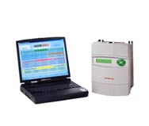

Part #

Profibus card Profibus card Devicenet card Devicenet card Mounting board for Profibus/Devicenet card LA102738
Additional Drive to PC comms cable LA102595
Drive to drive cable FCC68/FCC68 LA102596

PLA

Part #
PLA Applications module PLA

PLXD

Part #
PLXD stack driver PLXD
Pulse transformer board LA102800

SLE range, Trójfazowy 2Q Analogowy DC Controller

SLE14 14KW 34A
Controller Part # SLE14
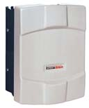

Line reactor Part # LR48
Main semiconductor Fuse, 3 required 14 x 51 Part # CH00740A Main Fuseholder, 3 required 14 x 51 Part # CP102053
Aux semiconductor Fuse, 3 required 6 x 32 Part # CH00608A Aux Fuseholder, 3 required 6 x 32 Part # CP102071
DIN Rail Clip for Aux fuseholder, 3 required. Part # FE101969
Pot kit incl graduated dial & knob Part # POTKIT

SLE24 24KW 58A
Controller Part # SLE24
Line reactor Part # LR48
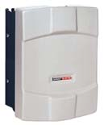

Main semiconductor Fuse, 3 required Size OOO Part # CH00880A Main Fuseholder, 3 required Size OOO Part # CP102054
Aux semiconductor Fuse, 3 required 6 x 32 Part # CH00608A Aux Fuseholder, 3 required 6 x 32 Part # CP102071
DIN Rail Clip for Aux- fuseholder, 3 required. Part # FE101969
Pot kit incl graduated dial & knob Part # POTKIT

Please refer to catalogue for further information or product technical manual for full specification.

Strona 16

SLE34 34KW 82A
Controller Part # SLE34

Line reactor Part # LR120
Main semiconductor Fuse, 3 required Size OOO Part # CH00880A Main Fuseholder, 3 required Size OOO Part # CP102054
Aux semiconductor Fuse, 3 required 6 x 32 Part # CH00608A Aux Fuseholder, 3 required 6 x 32 Part # CP102071
DIN Rail Clip for Aux- fuseholder, 3 required. Part # FE101969
Pot kit incl graduated dial & knob Part # POTKIT

SLE44 44KW 106A
Controller Part # SLE44
Line reactor Part # LR120

Main semiconductor Fuse, 3 required Size OOO Part # CH008100
Main Fuseholder, 3 required Size OOO Part # CP102054
Aux semiconductor Fuse, 3 required 6 x 32 Part # CH00608A Aux Fuseholder, 3 required 6 x 32 Part # CP102071
DIN Rail Clip for Aux- fuseholder, 3 required. Part # FE101969
Pot kit incl graduated dial & knob Part # POTKIT

SL range, Trójfazowy analogowy 2Q drive with integral field weakener

SL5 5KW 12A. This model has ze zwrotem energii stopping capability as standard
Controller Part # SL5
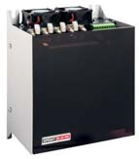

7.5 Amp option on field output
Line reactor Part # LR48
Main semiconductor Fuse, 3 required 6 x 32 Part # CH00612A Fuseholder, 3 required 6 x 32 Part # CP102071
DIN Rail Clip for holder,3 required Part # FE101969
Pot kit incl graduated dial & knob Part # POTKIT

SL10 10KW 24A. This model has ze zwrotem energii stopping capability as standard

Controller Part # SL10
7.5 Amp option on field output
Line reactor Part # LR48
Main semiconductor Fuse, 3 required 14 x 51 Part # CH00740A Main Fuseholder, 3 required 14 x 51 Part # CP102053
Pot kit incl graduated dial & knob Part # POTKIT

SL15 15KW 36A. This model has ze zwrotem energii stopping capability as standard
Controller Part # SL15

7.5 Amp option on field output
Line reactor Part # LR48
Main semiconductor Fuse, 3 required 14 x 51 Part # CH00740A Main Fuseholder, 3 required 14 x 51 Part # CP102053
Pot kit incl graduated dial & knob Part # POTKIT

SL20 20KW 48A. This model has ze zwrotem energii stopping capability as standard
Controller Part # SL20

7.5 Amp option on field output
Line reactor Part # LR48
Main semiconductor Fuse, 3 required Size OOO Part # CH00850A Main Fuseholder, 3 required Size OOO Part # CP102054
Pot kit incl graduated dial & knob Part # POTKIT

Visit www.sprint-electric.com for further information or product technical manual for full specification.
Strona 17

SL30 30KW 72A. This model has ze zwrotem energii stopping capability as standard
Controller Part # SL30

10 Amp option on field output
Line reactor Part # LR120
Main semiconductor Fuse, 3 required Size OOO Part # CH00880A Main Fuseholder, 3 required Size OOO Part # CP102054
Pot kit incl graduated dial & knob Part # POTKIT

SL40 40KW 96A. This model has ze zwrotem energii stopping capability as standard
Controller Part # SL40

10 Amp option on field output
Line reactor Part # LR120
Main semiconductor Fuse, 3 required Size OOO Part # CH008100
Main Fuseholder, 3 required Size OOO Part # CP102054
Pot kit incl graduated dial & knob Part # POTKIT

SL50 50KW 120A. This model has ze zwrotem energii stopping capability as standard
Controller Part # SL50

10 Amp option on field output
Line reactor Part # LR120
Main semiconductor Fuse, 3 required Size OOO Part # CH008125
Main Fuseholder, 3 required Size OOO Part # CP102054
Pot kit incl graduated dial & knob Part # POTKIT

SL65 65KW 155A
Controller Part # SL65
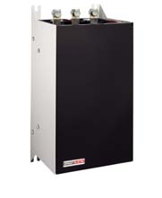

15 Amp option on field output
Line reactor Part # LR270
Main semiconductor Fuse, 3 required Size OOO Part # CH008160
Main Fuseholder, 3 required Size OOO Part # CP102054
Aux semiconductor Fuse, 3 required 6 x 32 Part # CH00620A Aux Fuseholder, 3 required 6 x 32 Part # CP102071
DIN Rail Clip for Aux- fuseholder, 3 required. Part # FE101969
Pot kit incl graduated dial & knob Part # POTKIT

SL85 85KW 205A
Controller Part # SL85

15 Amp option on field output
Line reactor Part # LR270
Main semiconductor Fuse, 3 required Size 1 Part # CH009250
Main 3 pole Fuseholder Size 1 Part # CP102055
Aux semiconductor Fuse, 3 required 6 x 32 Part # CH00620A Aux Fuseholder, 3 required 6 x 32 Part # CP102071
DIN Rail Clip for Aux- fuseholder, 3 required. Part # FE101969
Pot kit incl graduated dial & knob Part # POTKIT

SL115 115KW 270A
Controller Part # SL115

15 Amp option on field output
Line reactor Part # LR270
Main semiconductor Fuse, 3 required Size 1 Part # CH009250
Main 3 pole Fuseholder Size 1 Part # CP102055
Aux semiconductor Fuse, 3 required 6 x 32 Part # CH00620A Aux Fuseholder, 3 required 6 x 32 Part # CP102071
DIN Rail Clip for Aux- fuseholder, 3 required. Part # FE101969

Please refer to catalogue for further information or product technical manual for full specification.
Strona 18

Pot kit incl graduated dial & knob Part # POTKIT

SL145 145KW 330A This model has ze zwrotem energii stopping capability as standard
Controller Part # SL145
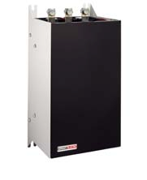

15 Amp option on field output
Line reactor Part # LR330
Main semiconductor Fuse, 3 required Size 3 Part # CH010550
Main 3 pole Fuseholder Size 3 Part # CP102233
Aux semiconductor Fuse, 3 required 6 x 32 Part # CH00620A Aux Fuseholder, 3 required 6 x 32 Part # CP102071
DIN Rail Clip for Aux- fuseholder, 3 required. Part # FE101969
Pot kit incl graduated dial & knob Part # POTKIT

SLX range, Trójfazowy 4Q fully ze zwrotem energii analogowy controller with integral field weakener

SLX5 5KW 12 Amp 4Q
Controller Part # SLX5
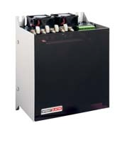

7.5 Amp option on field output
Line reactor Part # LR48
Main semiconductor Fuse, 3 required 6 x 32 Part # CH00612A Fuseholder, 3 required 6 x 32 Part # CP102071
DIN Rail Clip for holder,3 required Part # FE101969
Armature fuse Part # CH00816A Armature fuseholder Part # CP102906
Pot kit incl graduated dial & knob Part # POTKIT

SLX10 10KW 24 Amp 4Q
Controller Part # SLX10
7.5 Amp option on field output

Line reactor Part # LR48
Main semiconductor Fuse, 3 required 14 x 51 Part # CH00740A Main Fuseholder, 3 required 14 x 51 Part # CP102053
Armature fuse Part # CH00832A Armature fuseholder Part # CP102906
Pot kit incl graduated dial & knob Part # POTKIT

SLX15 15KW 36 Amp 4Q
Controller Part # SLX15

7.5 Amp option on field output
Line reactor Part # LR48
Main semiconductor Fuse, 3 required 14 x 51 Part # CH00740A Main Fuseholder, 3 required 14 x 51 Part # CP102053
Armature fuse Part # CH00940A Armature fuseholder Part # CP102906
Pot kit incl graduated dial & knob Part # POTKIT

SLX20 20KW 48 Amp 4Q
Controller Part # SLX20

7.5 Amp option on field output
Line reactor Part # LR48
Main semiconductor Fuse, 3 required Size OOO Part # CH00850A Main Fuseholder, 3 required Size OOO Part # CP102054
Armature fuse Part # CH00963A Armature fuseholder Part # CP102906
Pot kit incl graduated dial & knob Part # POTKIT

Visit www.sprint-electric.com for further information or product technical manual for full specification.
Strona 19

SLX30 30KW 72 Amp 4Q
Controller Part # SLX30

10 Amp option on field output
Line reactor Part # LR120
Main semiconductor Fuse, 3 required Size OOO Part # CH00880A Main Fuseholder, 3 required Size OOO Part # CP102054
Armature fuse Part # CH00980A Armature fuseholder Part # CP102906
Pot kit incl graduated dial & knob Part # POTKIT

SLX40 40KW 96 Amp 4Q
Controller Part # SLX40

10 Amp option on field output
Line reactor Part # LR120
Main semiconductor Fuse, 3 required Size OOO Part # CH008100
Main Fuseholder, 3 required Size OOO Part # CP102054
Armature fuse Part # CH009125
Armature fuseholder Part # CP102906
Pot kit incl graduated dial & knob Part # POTKIT

SLX50 50KW 120 Amp 4Q
Controller Part # SLX50

10 Amp option on field output
Line reactor Part # LR120
Main semiconductor Fuse, 3 required Size OOO Part # CH008125
Main Fuseholder, 3 required Size OOO Part # CP102054
Armature fuse Part # CH009160
Armature fuseholder Part # CP102906
Pot kit incl graduated dial & knob Part # POTKIT

SLX65 65KW 155 Amp 4Q
Controller Part # SLX65
15 Amp option on field output

Line reactor Part # LR270
Main semiconductor Fuse, 3 required Size OOO Part # CH008160
Main Fuseholder, 3 required Size OOO Part # CP102054
Aux semiconductor Fuse, 3 required 6 x 32 Part # CH00620A Aux Fuseholder, 3 required 6 x 32 Part # CP102071
DIN Rail Clip for Aux- fuseholder, 3 required. Part # FE101969
Armature fuse Part # CH009200
Armature fuseholder Part # CP102906
Pot kit incl graduated dial & knob Part # POTKIT

SLX85 85KW 205 Amp 4Q
Controller Part # SLX85
15 Amp option on field output

Line reactor Part # LR270
Main semiconductor Fuse, 3 required Size 1 Part # CH009250
Main 3 pole Fuseholder Size 1 Part # CP102055
Aux semiconductor Fuse, 3 required 6 x 32 Part # CH00620A Aux Fuseholder, 3 required 6 x 32 Part # CP102071
DIN Rail Clip for Aux- fuseholder, 3 required. Part # FE101969
Armature fuse Part # CH009250
Armature fuseholder Part # CP102906
Pot kit incl graduated dial & knob Part # POTKIT

Please refer to catalogue for further information or product technical manual for full specification.
Strona 20

SLX115 115KW 270 Amp 4Q
Controller Part # SLX115
15 Amp option on field output

Line reactor Part # LR270
Main semiconductor Fuse, 3 required Size 1 Part # CH009250
Main 3 pole Fuseholder Size 1 Part # CP102055
Aux semiconductor Fuse, 3 required 6 x 32 Part # CH00620A Aux Fuseholder, 3 required 6 x 32 Part # CP102071
DIN Rail Clip for Aux- fuseholder, 3 required. Part # FE101969
Armature fuse Part # CH009315
Armature fuseholder Part # CP102906
Pot kit incl graduated dial & knob Part # POTKIT

SLX145 145KW 330 Amp 4Q
Controller Part # SLX145

15 Amp option on field output
Line reactor Part # LR330
Main semiconductor Fuse, 3 required Size 3 Part # CH010550
Main 3 pole Fuseholder Size 3 Part # CP102233
Aux semiconductor Fuse, 3 required 6 x 32 Part # CH00620A Aux Fuseholder, 3 required 6 x 32 Part # CP102071
DIN Rail Clip for Aux- fuseholder, 3 required. Part # FE101969
Armature fuse Part # CH009400
Armature fuseholder Part # CP102906
Pot kit incl graduated dial & knob Part # POTKIT

Niskonapięciowy controller. Servo performance, DC supply

200XLV 2 Amp 48v

Controller Part # 200XLV
Pot kit incl graduated dial & knob Part # POTKIT

Note.
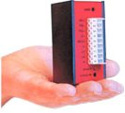

Also available are niskonapięciowy versions of all jedno fazowy models. Suitable for 30/60V ac input voltages, these regulator are ideal for motors with armature voltages of 24/48v d.c. Refer to Strona 8 for further details.

Visit www.sprint-electric.com for further information or product technical manual for full specification.
Strona 21

Drive Enclosures
0.37Kw 3 Amp Part # 300E
0.55Kw 4 Amp Part # 400E
1.1Kw 8Amp Part # 800E
1.8Kw 12 Amp Part # 1200E
0.55Kw 4 Amp - Reversing Part # 400ER
1.1Kw 8Amp - Reversing Part # 800ER
1.8Kw 12 Amp - Reversing Part # 1200ER
2.2Kw 16Amp 1600i enclosure Part # SE1600i
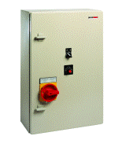

2.2Kw 8Amp 3200i/8 enclosure Part # SE3200i/8
4.0Kw 16Amp 3200i/16 enclosure Part # SE3200i/16
7.5Kw 32Amp 3200i/32 enclosure Part # SE3200i/32
11Kw 48Amp 3200i/48 enclosure Part # SE3200i/48
0.55Kw 4Amp 3600XRi/4 enclosure 4Q Part # SE3600XRi/4
1.1Kw 8Amp 3600XRi/8 enclosure 4Q Part # SE3600XRi/8
4.0Kw 16Amp 3600XRi/16 enclosure 4Q Part # SE3600XRi/16
7.5Kw 32Amp 3600XRi32 enclosure 4Q Part # SE3600XRi/32

Cyfrowy Panel Meters

3.5 digit Part # DPM35S
4.5 digit Part # DPM35SD
3.5 digit frequency meter Part # DPM35F
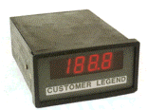

Ancillary Products
Buffer card Part # BUFFER Reversing unit Part # REVUNIT Winder Card Part # WINDER Frequency to Voltage converter Part # F2V

Setpoint potentiometer with graduated scale and knob.
Part # POTKIT

DB Assembly Dynamic Braking Assembly
Panel mounting IP20 enclosure for up to 9
resistors LA102182
Resistor 43Ω 1KW CX102183

Please refer to catalogue for further information or product technical manual for full specification.



Sprint Electric Limited

Rudford Industrial Estate
Ford
Arundel
West Sussex BN18 0BD United Kingdom

Tel (01903) 730000
Fax (01903) 730893

Email: info@sprint-electric.com
Web site: www.sprint-electric.com

