

Medium Voltage Soft starter
testing and Commissioning procedures

Edition: November 2011
VS65IM10CI Rev. C
SAFEty symbols
In order to reduce the risk of personal injury, electric shock, fire and damage to equipment, please read carefully and pay attention to the precautions found in this manual.

 | ALARM  SAFETY  WARNING | This symbol indicates the presence of potential hazard, which may result in serious personal injury when instructions are omitted or not followed properly.
 | CAUTION | Identifies shock hazards under certain conditions. Particular attention should be given due to the presence of dangerous voltage. Maintenance operations should be carried out by qualified personnel.
 |  | Identifies potential hazards under certain conditions. Read the message and follow the instructions carefully.
 |  | Identifies electric shock hazards under certain conditions. Particular attention should be given due to the presence of dangerous voltage.

November 2011 Edition
This publication could show technical imprecision or misprints. The information here included would be periodically modified and updated, included in later editions. To consult or download the latest information related to this product, please contact our website www.power-electronics.com.

REVISION CONTROL
DATE | REVISION | DESCRIPTION
March 2011 | A | First Edition
June 2011 | B | Data update
November 2011 | C | Data update

The equipment and technical documentation is periodically updated. Power electronics reserves the right to modify all or part of the contents within the manual without previous notice.

INDEX

1. Safety instructions……………………………………………………………………5

2. Configuration, Low Voltage trial and Commissioning..........................................8

2.1 Before Commissioning Observations…………………………………….8

2.2 Low voltage Trial…………………………………………………………..9

2.2.1 Material....................................................................................9

2.2.2 Wiring process before the test.................................................10

2.2.3 Test process............................................................................13

2.2.4 Test..........................................................................................14

2.2.5 Test ending and Medium voltage connection..........................14

3. Medium voltage commissioning…………………………………………………….15

3.1 Unloaded motor......................................................................................15

3.2 Loaded motor.........................................................................................16

1. Safety instructions
¡IMPORTANT!
The safety measures shown in the manual are intended to teach the user to use the product properly and as safely as possible to prevent any personal injury or material damage.

danger | caution |  alarm
DANGEROUS VOLTAGE  The medium voltage soft starters have dangerous voltages when connected to line voltage. Install and maintenance operations should be carried out by qualified personnel only.  An improper motor or soft starter installation may cause faults in the equipment, serious injuries including death. Follow carefully the instructions given in the manual, the national electric codes and updated local codes. | SHORT CIRCUIT  Medium Voltage soft starters are not tested against short circuits.  In case of a severe overload or short circuit, the soft starter should be completely tested to keep the equipment in working order , | GENERAL PROTECTIONS AND EARTH GOUNDING.  The installer or user is responsible to provide a proper soft starter earthing system and a complete protections system in accordance with the national electric codes and updated local codes.

ALARM – SAFEty – caution
Read carefully this manual and follow the instructions before proceeding.
All of the safety instructions would not cover every single potential equipment cause. However, the most common and important ones have been pointed out. The installer should follow the instructions described within the manual, provide quality electric work and localise all of the recommendations and warnings provided before starting the equipment.
Make sure the soft starter is completely disconnected from the power supply and earth grounded before any use or maintenance operation is carried out.
In order to prevent electric risks, disconnect the power supply input, earth ground the equipment and remove the control voltages before working in the equipment. Warning and safety labels should be properly placed in terminals, covers and control panels in accordance with local codes. Otherwise, electric shock hazard exists.
DO NOT CONNECT ANY KIND OF POWER SUPPLY TO THE EQUIPMENT WHILE THE DOORS ARE OPENED.
Totally prohibited to run the soft starter with the doors opened.
Once doors are properly closed, the power supply may be connected to the equipments power supply line. Otherwise, electric shock hazard exists.
Do not open the soft starter doors except for periodic inspections, wiring the unit even when the input voltage is not connected.
Otherwise, you may suffer an electric shock.

ALARM – SAFEty – caution
Power factor compensation capacitors.
The reactive compensation capacitors used to increase the power factor should be connected to the soft starter input terminals and not to the output ones. These capacitors should be connected with an additional contactor as shown in the electric connections section. The connection will be done only when the soft starter is running and it will be disconnected during the acceleration and deceleration ramp.
Otherwise, the soft starter can be damaged.
When working in electric installations always remember to apply the 5 golden rules:
1. Visible cut of all the voltage sources.
2. Mechanic lock of every single cut elements.
3. Verify no voltage is present.
4. Earth ground and short circuit any possible voltage source.
5. Define and post sign the working area.

caution
Handle the equipment with dry hands.
Otherwise, electric shock hazard existence.
Do not use cables with damaged insulation. Do not summit cables to abrasions, excessive stress, heavy loads or pinching.
Otherwise, electric shock hazard existence.
Keep clean the equipment, not allowing lint, paper, wooden chips, dust, metallic chips or other foreign matter (screws, pressure washers…) into the soft starter. Verify this point after the installation.
Otherwise, accident and fire risk existence.
Place the soft starter over non-flammable surface. Keep away from flammable materials.
Otherwise, fire risk existence.
Disconnect and earth ground the soft starter power input when the soft starter is damaged.
Otherwise, fire and secondary accident risk existence.
After applying input voltage or after removing it, the soft starter will remain warm for a couple of minutes.
Otherwise, body injury or skin burn risk existence.
Do not apply voltage to a damaged or soft starter with parts missing even if the installation is complete.
Otherwise, electric shock hazard existence.
Do not exchange the soft starter input and output power connections.
Otherwise, excessive voltage could be found in the logic control circuit.

SAFEty
COMMISSIONING
- Before commissioning the soft starter, the user must read carefully this manual and pay particular attention to the connection and start sections.
- Verify all of the parameters and make the necessary settings before starting the equipment. Depending on load and applications, the parameter values can be changed.
- Voltage and current levels applied in terminals as external signs should be in accordance with the manual data. Otherwise, the soft starter could be damaged.

Warnings
RECEPTION
- The VS65 Series soft starters are handled carefully tested and perfectly packed.
- In the even of transport damage, please ensure that you notify the transport agency and Power Electronics: 902 40 20 70 (International + 34 96 136 65 57).
UNPACKING
- Verify model and serial number of the soft starter is the same on the box, delivery note and unit.
- Each soft starter is supplied with an installation manual.
RECICLYING
- Packing of the equipments should be recycled. Therefore, it is necessary to separate materials included (plastic, paper, cardboard, Wood….) and deposit them on proper recycling banks.
- Waste products of electric and electronic devices should be selectively collected for their correct environmental management.
SAFETY
- Before starting the soft starter, read this manual completely to gain an understanding of the unit. In case of doubt, please contact Power Electronics (902 40 20 70 / +34 96 136 65 57) or your nearest agent.
- Wear safety goggles when operating the soft starter with voltage.
- Handle the equipment in accordance with the soft starters’ weight.
- Proceed with the installation according to the instructions found in this manual.
- Do not place heavy objects on the soft starter.
- Ensure that the mounting orientation is correct.
- Do not drop the soft starter or to impact exposure.
- The VS65 Series soft starters contain static-sensitive printed circuit boards. Use static safety procedures when handling boards.
- Avoid installing the soft starter in different conditions form those described in the Technical Characteristics section

2. Configuration, Low Voltage trial and Commissioning

2.1 Before Commissioning Observations
- Check no foreign matter is found inside the equipment.
- Verify the auxiliary power supply is 230VAC ±10%.
- Verify the interconnection signs are correct and in accordance with the manual.
- Check the soft starter power supply is connected to the L1, L2, L3 terminals and the motor power supply to U, V, W terminals. Confirm that the triphasic voltage at soft starters input is within the specifications and the motor characteristics plate is in accordance with the equipment installed.
Note: The VS65 are factory configured to: START, STOP, RESET from keyboard.
- The digital input state can be checked on the screen EDG X 0 0 0 0 F
X indicates the input is active, 0 means the digital input has not been activated for the moment.
K indicates that the motor PTC is not active and F that the PTC input is active.
- Firstly, control through the digital inputs is disabled by the screen [G6.1 CONTROL MODE=1 LOCAL]. This means the soft starters run and stop is carried out by display and any modification of the digital inputs will have no major consequence than the screen 8isualization EDG= 0000K.
- Default relay configuration:
Relay 1: Instantaneous. Connected at the beginning of the acceleration ramp and disconnected at the end of the deceleration ramp.
Relay 2: Reactive or Bypass. Connected at the end of the acceleration ramp and disconnected at the beginning of the deceleration ramp.
Relay 3: Fault (Active in case of fault).
- Make sure the STOP circuit is open before configuring the soft starter in 3-strings mode.
- Configure motor start and stop parameters, protections and user parameters required for the application.
2.2 Low voltage Trial
CAUTION
Only qualified personal can make this test.
Otherwise, the equipment can be damaged and you may suffer electric shocks.
After treat all the things explained before, it is necessary to perform a low voltage test to allow the personnel check soft starter’s electric configuration safely and in which test makers don’t need special tools.
The VS65 is able to start and stop a low voltage three-phase motor, using only a low voltage transformer connected instead of the medium voltage transformer.
This test will be first made in the Power Electronics facilities, where the test conditions can be simulated. After, in the customer installation, it will be necessary to repeat the same test before connecting the soft starter to the medium voltage network. Power Electronics qualified personnel must always make this test.

2.2.1 Material
The following tools are needed to perform the low voltage test:
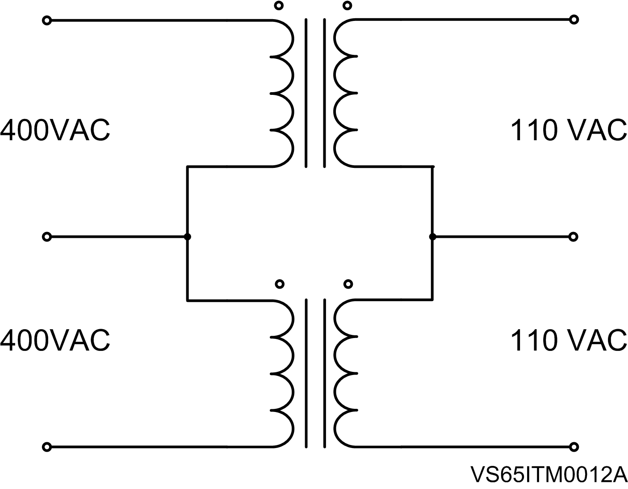
- A low voltage 400/110VAC, 500VA transformer is needed for soft starters.

Figure 5.11 Low voltage test transformer
- Three 300kΩ / 6W resistors (one per phase).
- Three test bulbs of 100W and 230VAC with star connection as it is shown in the following figure. The terminals U, V and W will receive 400VAC when the equipment is connected to this voltage and started.
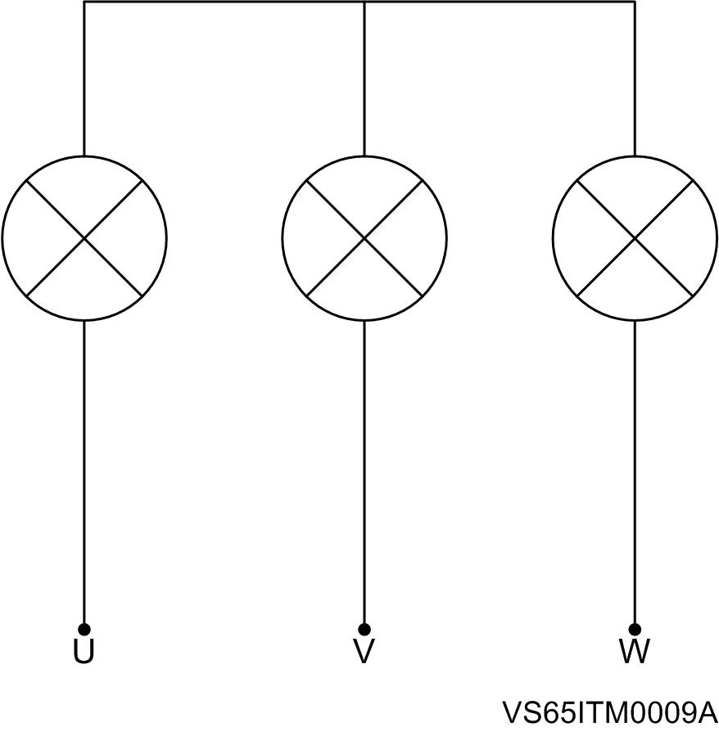

Figure 5.12 Connection of the test bulbs
- One low voltage three-phase motor of around 1CV.
- One low voltage three-phase motor of around 200Kw.

2.2.2 Wiring process before the test
To realize the low voltage test, these instructions should be followed:
- Disconnect the medium voltage transformer cables from the primary and secondary (low and medium voltage cables). This transformer is located next to the thyristors.
- Connect then the 400/110VAC transformer instead of the Medium Voltage transformer, its connection is shown in the following drawing. The low voltage transformer’s input will be 400VAC when it’s connected to the equipment terminals (L1, L2 and L3) and then power supply is provided to the soft starter.
In the case of soft starters with a rated voltage of 6000V, the low voltage transformer output will provide 110VAC to the cables A601, B601 and C601. The objective of this method is to work with low voltage instead of medium voltage to make the test safely.
In the case of soft starters with a rated voltage of 4160V, the low voltage transformer output will provide 110VAC to the terminals 1, 4 and 8 of the X3 terminal block placed above the toroidal transformer. These terminals correspond to the wires A605, B605 and C605.
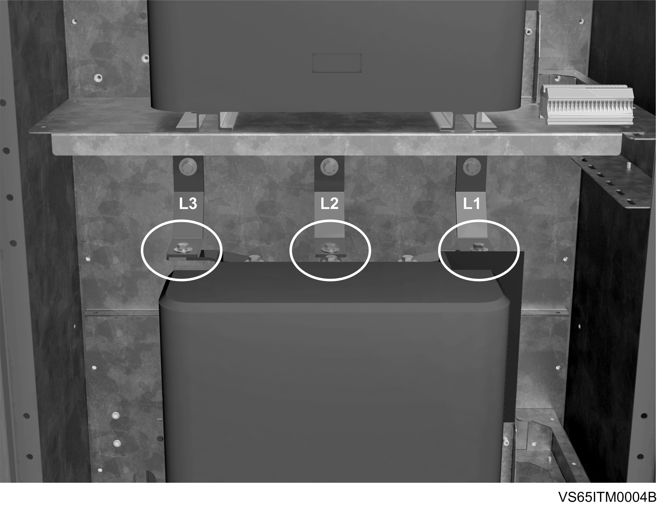
To connect the low voltage transformer’s cables it’s indispensable to consider the phases order, use a phase meter to make this connection easier.

Figure 5.13 Connection of the 400VAC low voltage transformer’s wires

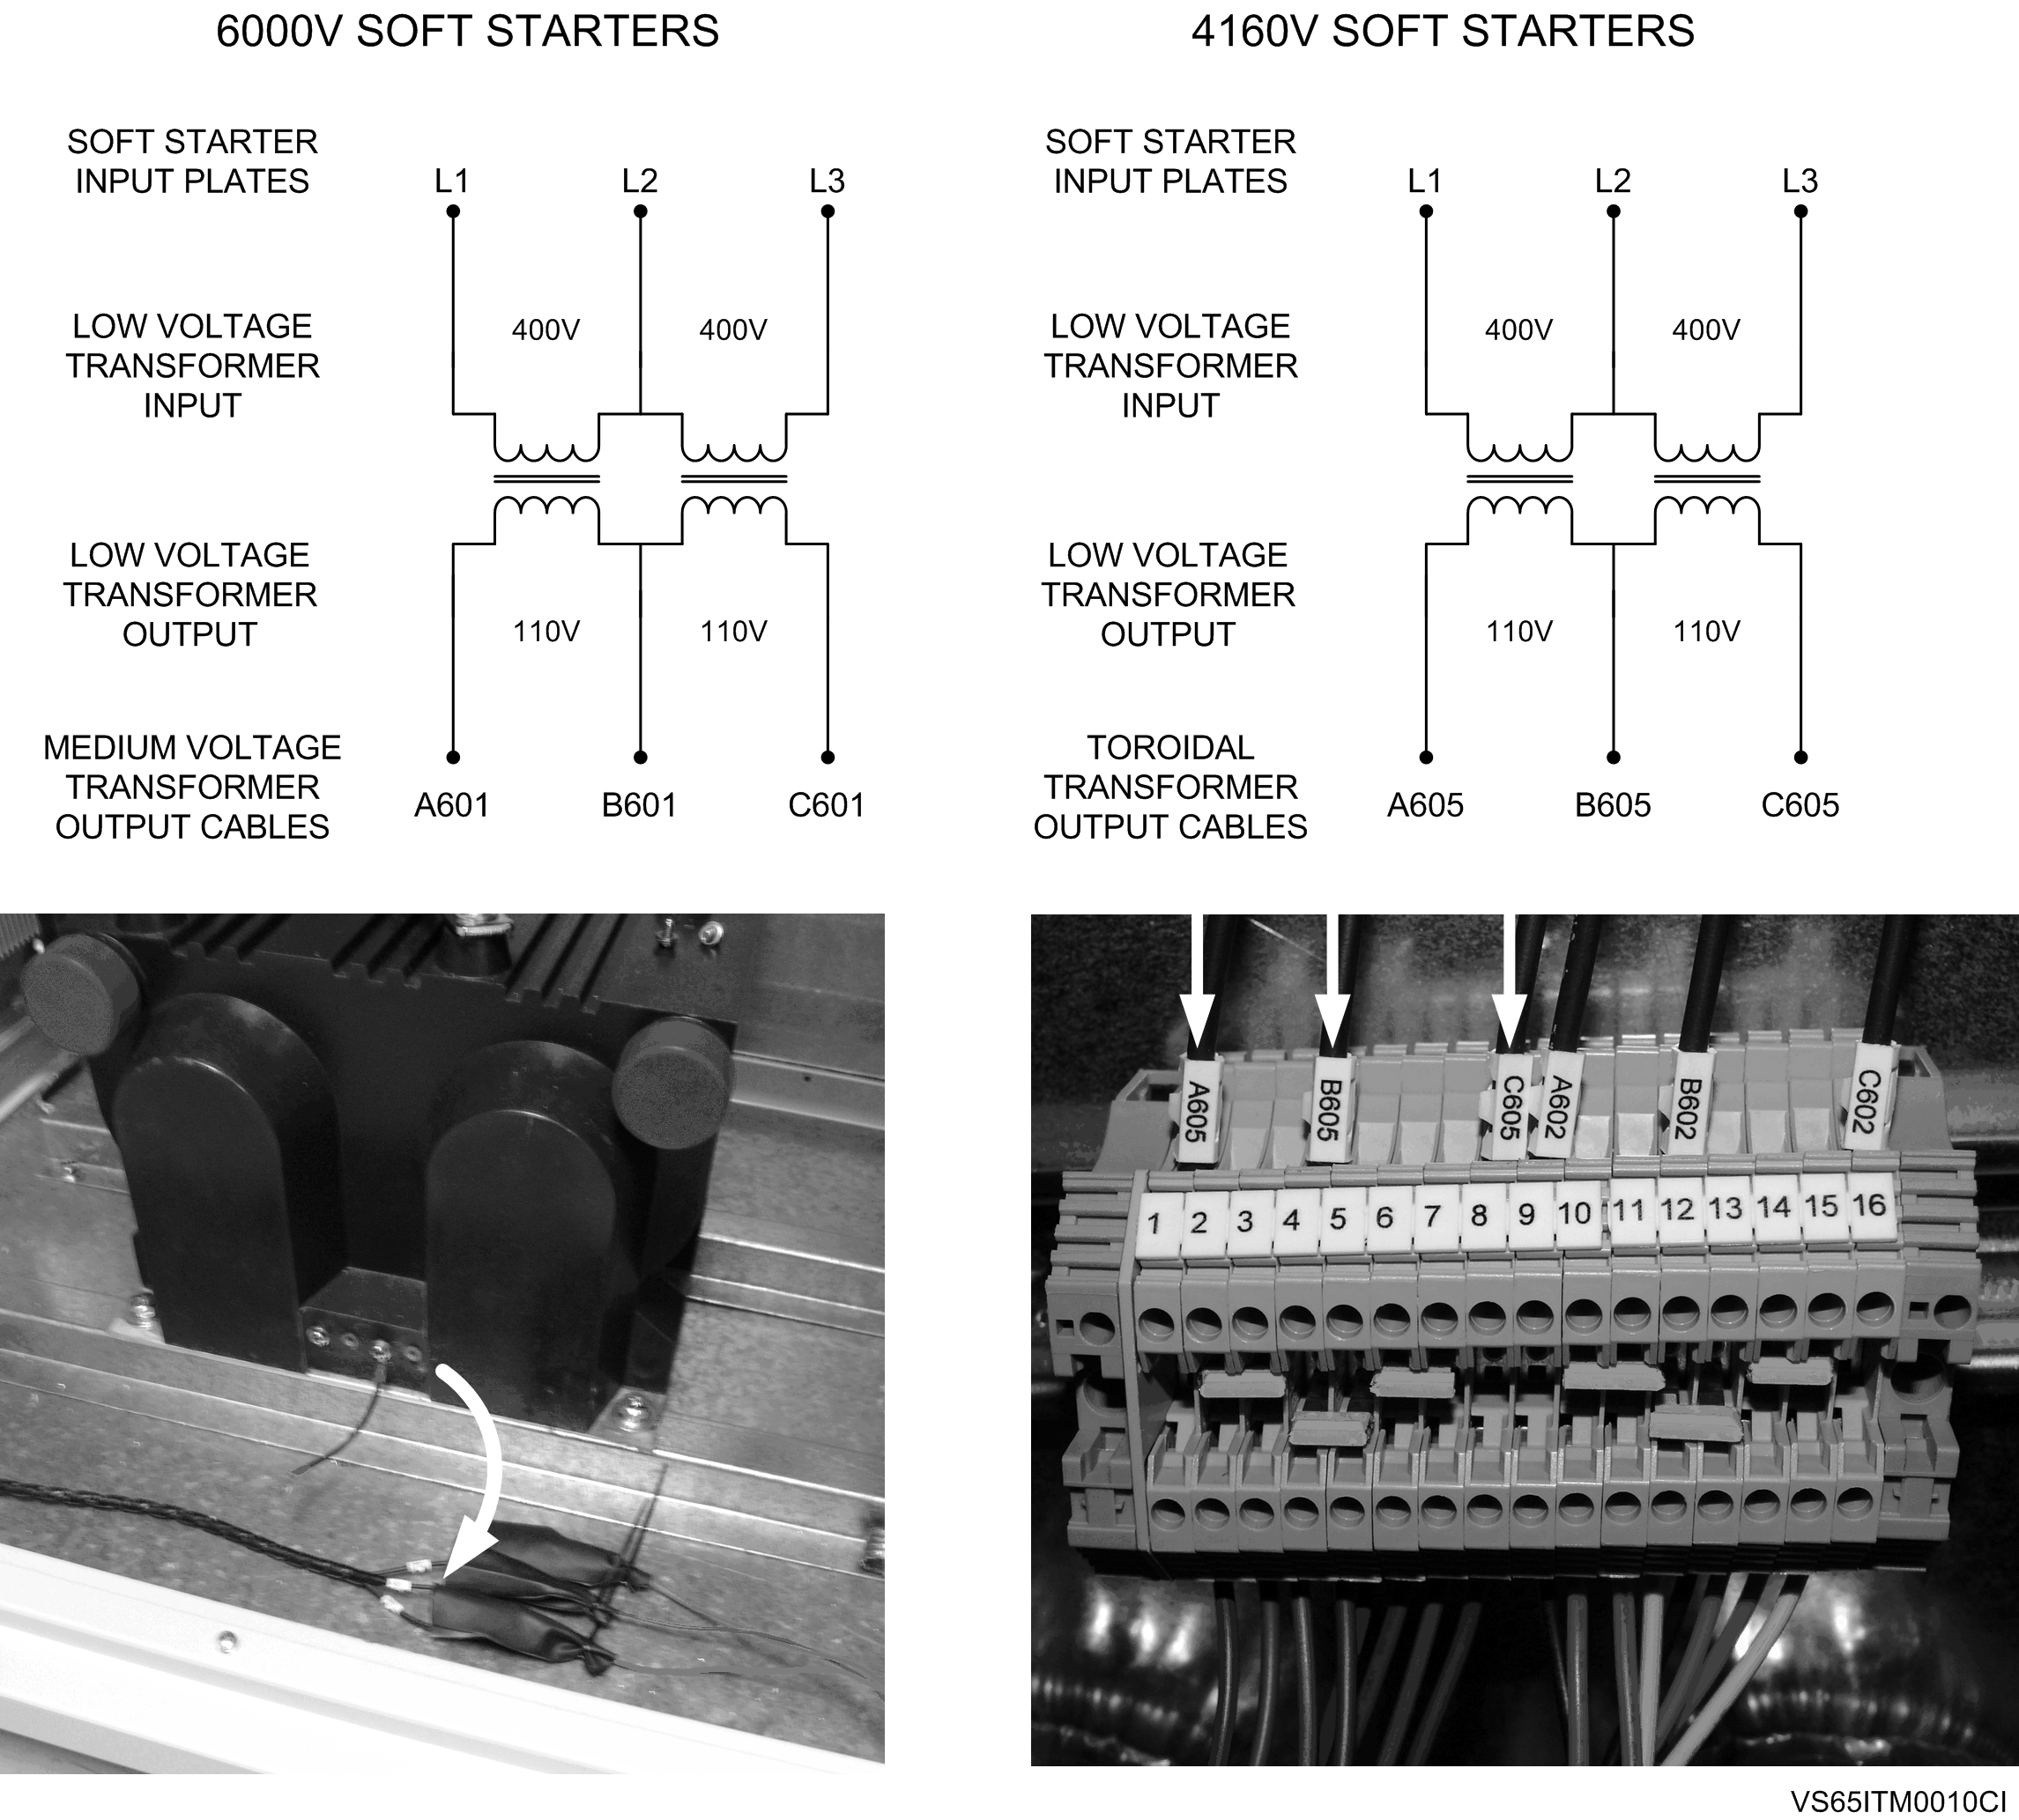
Figure 5.14 Connection of the 110VAC low voltage transformer’s wires

- Provide 230VAC auxiliary power supply to the X4 terminal block, placed in the superior door.
- 300kΩ resistor should be connected in each phase, making an electrical bridge in the medium voltage resistors, in the input of the first thyristors (terminal block JP2, terminal K) and in the phase output (terminal block JP2, terminal RF).
CAUTION
Make sure that IN EACH PHASE has been connected a 300kΩ resistor.
Otherwise, the equipment can be damaged.
Then the connections will be detailed for an only phase. The same steps should be done in the three phases.

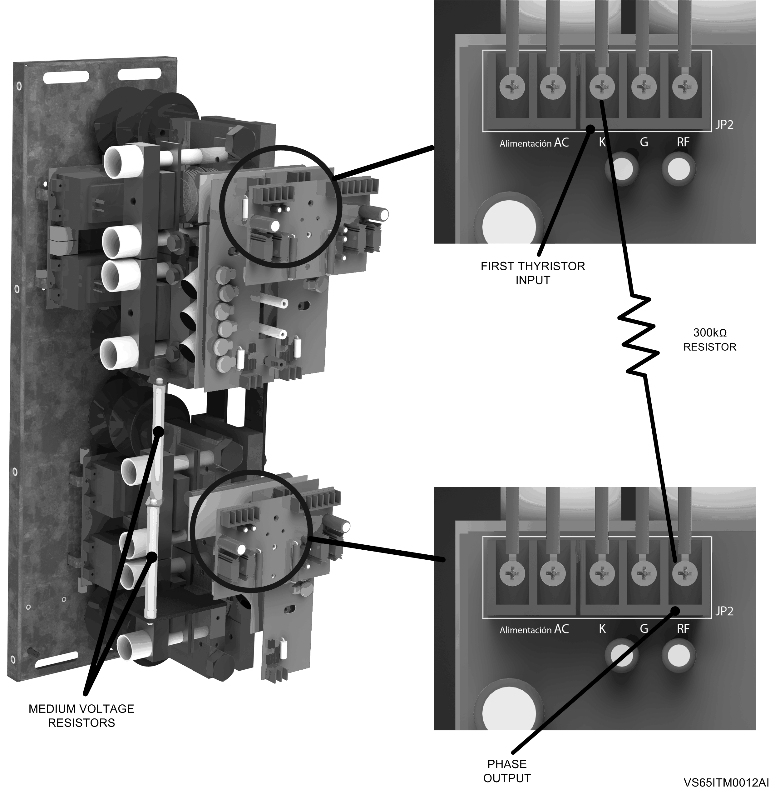
Figure 5.15 Connection of the 300kΩ resistor in the trigger boards per phase in the medium
voltage soft starters of 4160V or lower rated voltage

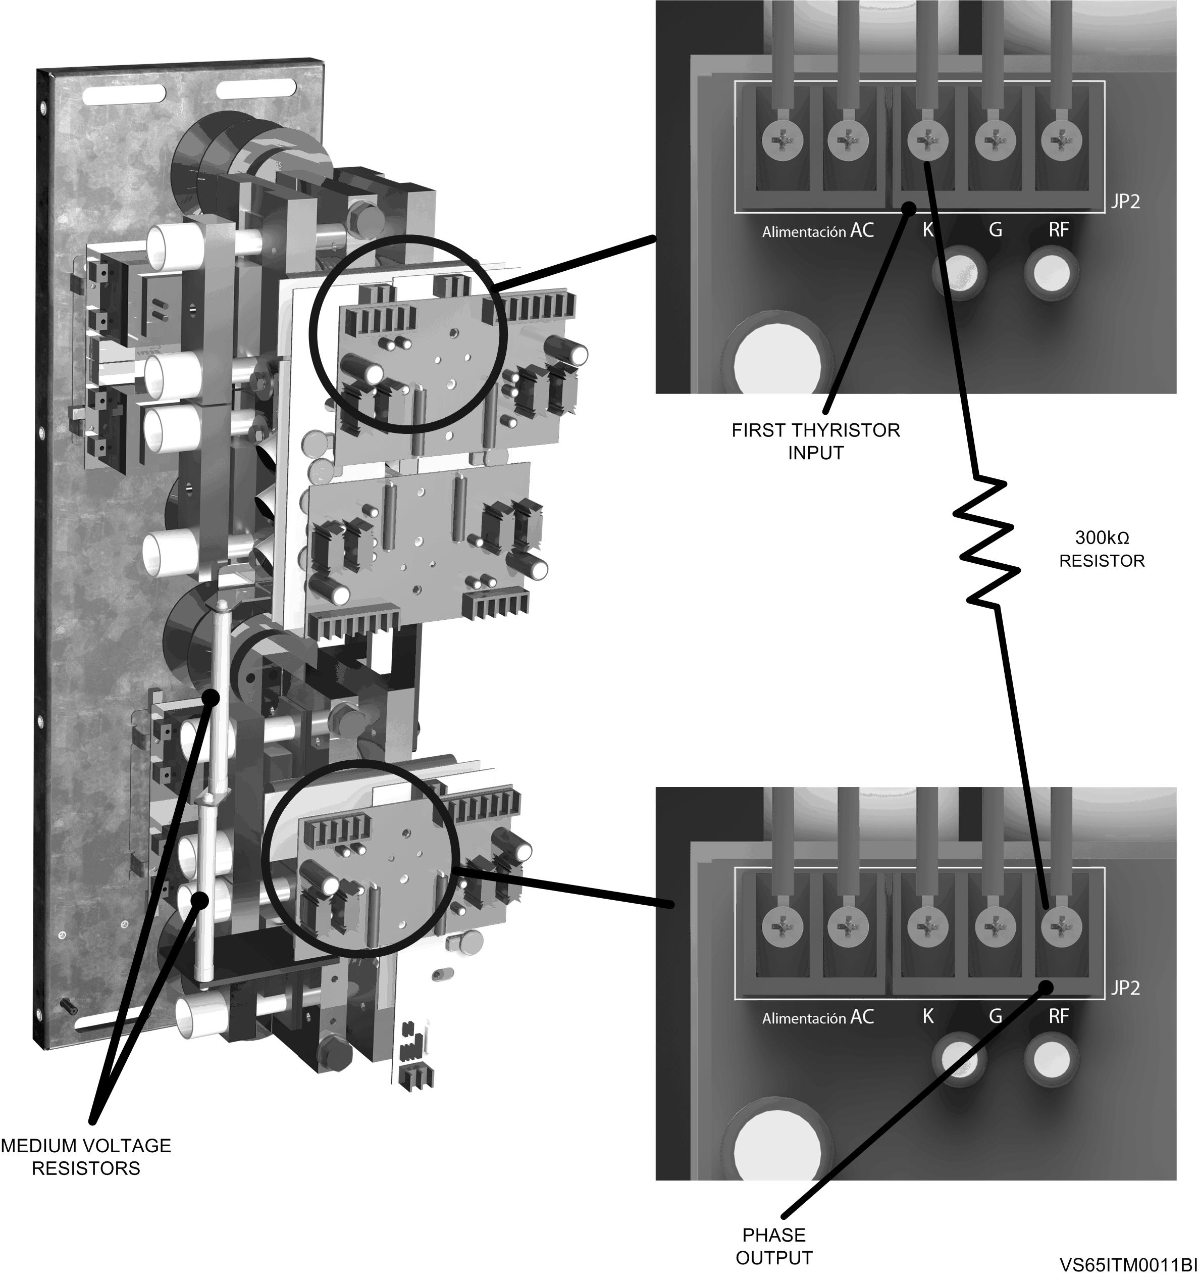
Figure 5.16 Connection of the 300kΩ resistor in the trigger boards per phase in the medium voltage
soft starters of 6000V or higher rated voltage
- Connect the soft starter input to 400VAC through the terminals L1, L2 and L3.

2.2.3 Test process
This process consists on three similar tests with different output components during each start.
- Use the three bulbs to realize the first test.
- The three-phase motor of around 1CV should be connected in parallel with the three bulbs to realize the second test.
- Use the three-phase motor of 200kW to realize the third test.

2.2.4 Test
- Keep pressed the inferior door switch during the test. Otherwise, the soft starter will not start.
CAUTION
When the door is opened and the door switch is pressed the personal protections of the equipment are disabled. These tests must be always made by qualified personal.
- Turn on the circuit breakers located in the low voltage cabinet. That will turn on the red light “power supply connected” and the green light “cradle connected”.
- Close the superior door and keep the main door opened. Select the soft start mode LOCAL. The display, the electronic board, the white pilot “soft starter ready” and the red pilot “soft starter stopped” will be turned ON.
- Push the green button “start”. The soft starter applies a start ramp (the display will show it). It’s recommended to make a visual inspection of the trigger boards. Their leds will be enabled showing their correct interconnection and the correct thyristors’ trigger. Check that the start is progressive. For example, in the case of the bulbs test, they make a progressive increase of its illumination.
- When the start ramp is finished, the bypass contactor will be enabled and the line contactor will work for 1 second before being disabled. The green pilot “soft starter running” will be turned on, and the red pilot “soft starter stopped” and the white pilot “soft starter ready” will be turned off. The equipment is at this moment working in bypass mode until it has to stop.
- To stop the soft starter, push the red “stop” button. The line contactor will be enabled and the bypass contactor will be working for a second and then disabled.
- During the deceleration ramp, check another time if the trigger boards’ leds are turned on like in the start ramp.
- When the deceleration ramp is finished, the green pilot “soft starter running” will be turned off, and the white pilot “soft starter ready” and the red pilot “soft starter stopped” will be turned on.
- After making the three tests, stop pressing the door switch.

2.2.5 Test ending and Medium voltage connection
- Disconnect the 400VAC voltage of the input plates. Check that there’s no voltage in the plates with a voltmeter.
- Connect all the wires as they were at the beginning (the equipment to 230VAC, the medium voltage transformer and the soft starter’s input to medium voltage (2.3kV, 3.3kV, 6kV…)).
- Disconnect the resistors of 300kΩ of the trigger boards and connect again the medium voltage transformer’s wires.
- If the tests are correctly performed, the equipment is ready to begin the medium voltage start.
- CLOSE the soft starter doors and verify that all of the safety devices are active and there is no risk present when the motor starts.
- Start the equipment with medium voltage in the required mode.
- Set the display parameter groups (G2, G4 and G5) and the equipment will be ready to start the motor with medium voltage.

3. Medium voltage commissioning

3.1 Unloaded motor
Once the previous points are checked, and with the medium voltage motor connected but unloaded or uncoupled from the axis load, follow the next tasks.
- Verify the properly connection and torque of the VS65 output power terminals.
- Verify the properly connection and torque of the VS65 medium voltage input power terminals.
- Check that the VS65 cabinet doors are correctly closed
With 220Vac voltage tension (Control power supply) we proceed to configure the parameters to start-up the medium voltage motor unloaded.

SCREENS | RANGE |  |  |  | UNLOADED MOTOR COMMISSIONING CONFIGURATION
G2 NAMEPLATE
1 ISTARTER= | 9 - 1600 |  |  |  | _ _ _A*
2 I MOTOR= | 1 - 1600 |  |  |  | _ _ _A *
3 V MOTOR= | 1/2/3/4 |  |  |  | 4 (6000V)
4 P MOTOR= | 4 - 999 |  |  |  | _ _ _KW
5 COS PHI M= | 40 – 99% |  |  |  | 87%
6 FREQ= | 50/60 |  |  |  | 50Hz
G3 PROTECTIONS
1 PHASE SEQUEN= | 1/2/3 |  |  |  | SEC L1/L2/L3
G4 ACCELERATION
1 STR DELAY= | 0-600 |  |  |  | 1s
3 PULS TQ T= | 0,1-0,9/Off |  |  |  | OFF
4 INIT TORQ= | 0-100% |  |  |  | 30%
5 INIT TQ T= | 0-99 |  |  |  | 0s
6 ACEL TIME= | 0-180 |  |  |  | 6s
7 I LIMIT= | 1.5 - 5 x In |  |  |  | 3 X Im
G5 DECELERATION
1 FREWEL STP= | Yes/No |  |  |  | YES
2 DECL TIME= | 0-180 |  |  |  | 12s

 | G6 INPUTS
 | 1 OPER MODE= |  |  | 1/2/3/4/5 |  |  |  |  | 2
 | 3 DINPUT1 SEL= |  |  | 0-10 |  |  |  |  | 4
 | 4 DINPUT2 SEL= |  |  | 0-10 |  |  |  |  | 0
 | 5 DINPUT3 SEL= |  |  | 0-10 |  |  |  |  | 0
 | 6 DINPUT4 SEL= |  |  | 0-10 |  |  |  |  | 0
 | 7 DINPUT5 SEL= |  |  | 0-10 |  |  |  |  | 0

G7 OUTPUTS
1 REL1 SEL ON= | 1-21 |  | 14
2 REL2 SEL ON= | 1-21 |  | 15
3 REL3 SEL ON= | 1-21 |  | 9

Once the previous points have been checked carefully by qualified personnel, who will have extended knowledge about the medium voltage installations operation, the following task will be carried out:
- Disconnect the ground connections.
- Connect the medium voltage switch.
- Connect the medium voltage input power VS65 terminals.
- Verify the input VS65 voltage in the analogic voltmeter.
- Verify externally the input VS65 voltage.
- Proceed to start remotely by PLC the motor and verify the rotation direction.

3.2 Loaded motor

Once the unloaded motor start-up has finished correctly, the qualified technician will open the circuit breaker and the switch and will connect the grounds. Next, the motor load should be connected to the motor.
Check the process conditions to guarantee a safety and correct start –up.
For a wide variety of applications the following start-up parameters are valid.

SCREENS | RANGE |  |  |  | LOADED MOTOR COMMISSIONING CONFIGURATION
G2 NAMEPLATE
1 ISTARTER= | 9 - 1600 |  |  |  | _ _ _A*
2 I MOTOR= | 1 - 1600 |  |  |  | _ _ _A *
3 V MOTOR= | 1/2/3/4 |  |  |  | 4 (6000V)
4 P MOTOR= | 4 - 999 |  |  |  | _ _ _KW
5 COS PHI M= | 40 – 99% |  |  |  | 87%
6 FREQ= | 50/60 |  |  |  | 50Hz
G3 PROTECTIONS
1 PHASE SEQUEN= | 1/2/3 |  |  |  | SEC L1/L2/L3
G4 ACCELERATION
1 STR DELAY= | 0-600 |  |  |  | 1s
3 PULS TQ T= | 0,1-0,9/Off |  |  |  | OFF
4 INIT TORQ= | 0-100% |  |  |  | 40%
5 INIT TQ T= | 0-99 |  |  |  | 1s
6 ACEL TIME= | 0-180 |  |  |  | 8s
7 I LIMIT= | 1.5 - 5 x In |  |  |  | 3.5 X Im
G5 DECELERATION
1 FREWEL STP= | Yes/No |  |  |  | YES
2 DECL TIME= | 0-180 |  |  |  | 12s

 | G6 INPUTS
 | 1 OPER MODE= |  |  | 1/2/3/4/5 |  |  |  |  | 2
 | 3 DINPUT1 SEL= |  |  | 0-10 |  |  |  |  | 4
 | 4 DINPUT2 SEL= |  |  | 0-10 |  |  |  |  | 0
 | 5 DINPUT3 SEL= |  |  | 0-10 |  |  |  |  | 0
 | 6 DINPUT4 SEL= |  |  | 0-10 |  |  |  |  | 0
 | 7 DINPUT5 SEL= |  |  | 0-10 |  |  |  |  | 0

G7 OUTPUTS
1 REL1 SEL ON= | 1-21 |  | 14
2 REL2 SEL ON= | 1-21 |  | 15
3 REL3 SEL ON= | 1-21 |  | 9
- Proceed to start remotely by PLC the motor.
- After the start up check the motor parameters, if they are under normal conditions, the commissioning has finished.

www.powerelectronics.es | www.power-electronics.com
24 Hours Technical Assistance 365 days a year +34 96 136 65 57

HEADQUARTER • VALENCIA • SPAIN
C/ Leonardo da Vinci, 24 – 26 • Parque Tecnológico • 46980 – PATERNA • VALENCIA • ESPAÑA
Tel. 902 40 20 70 • Tel. (+34) 96 136 65 57 • Fax (+34) 96 131 82 01
BRANCHES
CATALOÑIA | BARCELONA • Avda. de la Ferrería, 86-88 • 08110 • MONTCADA I REIXAC  Tel. (+34) 96 136 65 57 • Fax (+34) 93 564 47 52
CATALOÑIA | LLEIDA • C/ Terrasa, 13 · Bajo • 25005 • LLEIDA  Tel. (+34) 97 372 59 52 • Fax (+34) 97 372 59 52
CANARY ISLANDS | LAS PALMAS • C/ Juan de la Cierva, 4 • 35200 • TELDE  Tel. (+34) 928 68 26 47 • Fax (+34) 928 68 26 47
LEVANT | VALENCIA • Leonardo da Vinci, 24-26 • Parque tenológico ● 46980 ● PATERNA  Tel. (+34) 96 136 65 57 • Fax (+34) 96 131 82 01
LEVANT | CASTELLÓN • C/ Juan Bautista Poeta • 2º Piso · Puerta 4 • 12006 • CASTELLÓN  Tel. (+34) 96 136 65 57
LEVANT | MURCIA • Pol. Residencial Santa Ana • Avda. Venecia, 17 • 30319 • CARTAGENA  Tel. (+34) 96 853 51 94 • Fax (+34) 96 812 66 23
NORTH | VIZCAYA • Parque de Actividades • Empresariales Asuarán • Edificio Asúa, 1º B • Ctra. Bilbao · Plencia • 48950 • ERANDIO • Tel. (+34) 96 136 65 57 • Fax (+34) 94 431 79 08
CENTRE | MADRID • Avda. Rey Juan Carlos I, 98, 4º C • 28916 • LEGANÉS  Tel. (+34) 96 136 65 57 • Fax (+34) 91 687 53 84
SOUTH | SEVILLA • C/Arquitectura, Bloque 6 • Planta 5ª • Módulo 2 • Parque Empresarial Nuevo Torneo • 41015 • SEVILLA  Tel. (+34) 95 451 57 73 • Fax (+34) 95 451 57 73
INTERNATIONAL SUBSIDIARIES
GERMANY | Power Electronics Deutschland GmbH • Dieselstrasse, 77 • D·90441 • NÜRNBERG ● GERMANY  Tel. (+49) 911 99 43 99 0 • Fax (+49) 911 99 43 99 8
AUSTRALIA | Power Electronics Australia Pty Ltd • U6, 30-34 Octal St, Yatala, • BRISBANE, QUEENSLAND 4207 • P.O. Box 6022, Yatala DC, Yatala Qld 4207 • AUSTRALIA  Tel. (+61) 7 3386 1993 • Fax (+55) 11 5891 3769
BRAZIL | Power Electronics Brazil Ltda • Av. Guido Caloi, 1985-Galpão 09 • CEP 05802-140 • SÃO PAULO • BRASIL  Tel. (+55) 11 5891 9612 • Tel. (+55) 11 5891 9762
CHILE | Power Electronics Chile Ltda • Los Productores # 4439 – Huechuraba • SANTIAGO • CHILE  Tel. (+56) (2) 244 0308 · 0327 · 0335 • Fax (+56) (2) 244 0395  Oficina Petronila # 246, Casa 19 • ANTOFAGASTA • CHILE  Tel. (+56) (55) 793 965
CHINA | Power Electronics Beijing • Room 606, Yiheng Building • No 28 East Road, Beisanhuan • 100013, Chaoyang District • BEIJING • R.P. CHINA  Tel. (+86 10) 6437 9197 • Fax (+86 10) 6437 9181  Power Electronics Asia Ltd • 20/F Winbase Centre • 208 Queen’s Road Central • HONG KONG • R.P. CHINA
KOREA | Power Electronics Asia HQ Co • Room #305, SK Hub Primo Building • 953-1, Dokok-dong, Gangnam-gu • 135-270 • SEOUL • KOREA  Tel. (+82) 2 3462 4656 • Fax (+82) 2 3462 4657
INDIA | Power Electronics India • No 25/4, Palaami Center, • New Natham Road (Near Ramakrishna Mutt),• 625014 • MADURAI  Tel. (+91) 452 452 2125• Fax (+91) 452 452 2125
ITALY | Power Electronics Italia Srl • Piazzale Cadorna, 6 • 20123 • MILANO • ITALIA  Tel. (+39) 347 39 74 792
MEXICO | P.E. Internacional Mexico S de RL • Calle Cerrada de José Vasconcelos, No 9 • Colonia Tlalnepantla Centro • Tlalnepantla de Baz • CP 54000 • ESTADO DE MEXICO  Tel. (+52) 55 5390 8818 • Tel. (+52) 55 5390 8363 • Tel. (+52) 55 5390 8195
NEW ZEALAND | Power Electronics New Zealand Ltd • 12A Opawa Road, Waltham • CHRISTCHURCH 8023 • P.O. Box 1269 CHRISTCHURCH 8140  Tel. (+64 3) 379 98 26 • Fax.(+64 3) 379 98 27

