 | Rozdział | 12
 | Certyfikaty Falownika
 | Zawartość Strona
EC Declaration of Conformity (EMC Directive)
Manufacturer’s EMC Declaration
EC Declaration of Conformity (Low Voltage Directive)
Manufacturer’s Declaration

Certification for the Inverter

EC Declaration of Conformity (EMC Directive)
Issued for compliance with the EMC Directive when the unit is used as relevant apparatus.
EC DECLARATION OF CONFORMITY
In accordance with the EEC Directive 89/336/EEC,
Article 10 and Annex 1, (EMC DIRECTIVE)
We Eurotherm Drives Limited, address as below, declare under our sole responsibility that the
following Electronic Products
584SV (Type 8, 9 & 10)
When installed, used and CE marked in accordance with the instructions in the Product Manual
(provided with each piece of equipment) using the specified EMC filters to which this
declaration refers is in Conformity with the following standards:-
BSEN50081-2 (1994)
BSEN50082-1# (1992) & draft prEN50082-2#* (1992)
Following provisions of EEC- Directive
89/336/EEC with amendments 92/31/EEC and 93/68/EEC
.........................................  Dr Martin Payn,  Conformance Officer  Eurotherm Drives Ltd | 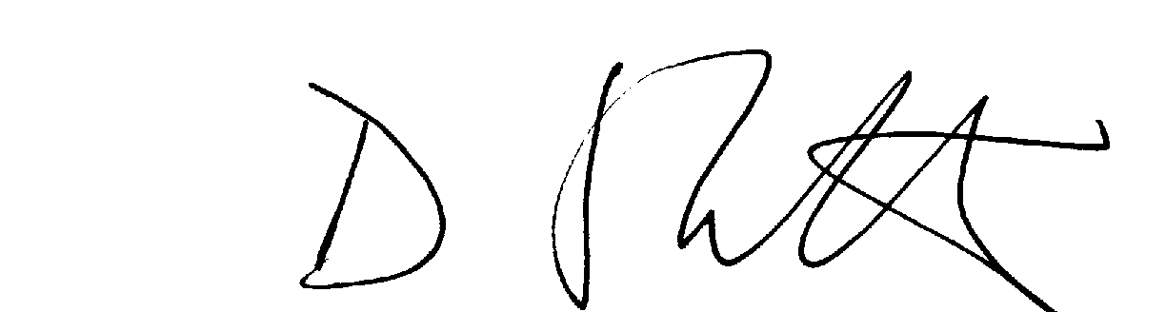  ..........................................  Dr Dan Slattery,  Technical Director  Eurotherm Drives Ltd |  | 4th March 1998  ......................................  Date
# Compliant with these immunity standards without specified EMC filters.
* For information only
EUROTHERM DRIVES LIMITED
NEW COURTWICK LANE, LITTLEHAMPTON, WEST SUSSEX BN17 7PD
TELEPHONE: 01903 721311 FAX: 01903 723938
Registered Number: 1159876 England. Registered Office: Leonardslee, Lower Beeding, Horsham, West Sussex RH13 6PP
© 1998 EUROTHERM DRIVES LIMITED
File Name: P:\PRODUCTS\CE\EMC\PRODUCTS\584SV\TYPE8\PRODFILE\A_389937.912
ISS: |  | DATE |  | DRN: | FEP | DRAWING NUMBER: |  | HK389937C912
 |  |  |  | CHKD: | MP | TITLE:
 | A  B |  | 19.06.97  04.03.98 |  |  |  | 584SV (Type 8, 9 &10)  EC Declaration of Conformity  for EMC |  |  | SHT 1  OF  1 SHTS
Issue D 20.02.1995 GA387648C017

Manufacturer’s EMC Declaration
This is provided to aid your justification for EMC compliance when the unit is used as a component.
MANUFACTURERS EMC DECLARATION
In accordance with the EEC Directive 89/336/EEC,
Article 10 and Annex 1, (EMC DIRECTIVE)
We Eurotherm Drives Ltd., address as below, declare under our sole responsibility
that the following electronic products
584SV (Type 8, 9 & 10)
When installed and used in accordance with the instructions in the product manual
(provided with each piece of equipment) and using the specified EMC filters
to which this declaration refers is in conformity with the following standards:-
BSEN50081-2 (1994)
BSEN50082-1# (1992) & draft prEN50082-2# * (1992)
Following provisions of EEC- Directive
89/336/EEC with amendments 92/31/EEC and 93/68/EEC
.........................................  Dr Martin Payn,  Conformance Officer  Eurotherm Drives Ltd |  | ..........................................  Dr Dan Slattery,  Technical Director  Eurotherm Drives Ltd | 4th March 1998  ......................................  Date
# Compliant with these immunity standards without specified EMC filters.
* For information only
EUROTHERM DRIVES LIMITED
NEW COURTWICK LANE, LITTLEHAMPTON, WEST SUSSEX BN17 7PD
TELEPHONE: 01903 721311 FAX: 01903 723938
Registered number: 1159876 England. Registered Office: Leonardslee, Lower Beeding, Horsham, West Sussex RH13 6PP
© 1998 EUROTHERM DRIVES LIMITED
File Name: P:\PRODUCTS\CE\EMC\PRODUCTS\584SV\TYPE8\PRODFILE\A_389937.914
ISS: |  | DATE |  | DRN: | FEP | DRAWING NUMBER: |  | HK389937C914
 |  |  |  | CHKD: | MP | TITLE:
 | A  B |  | 19.06.97  04.03.98 |  |  |  | 584SV (Type 8, 9 &10) Manufacturers EMC Declaration |  |  | SHT 1  OF  1 SHTS
Issue D 20.02.1995 GA387648C017

EC Declaration of Conformity (Low Voltage Directive)
The 585SV Inverter is CE marked in accordance with the low voltage directive for electrical equipment and appliances in the voltage range 50-1000V ac and 75-1500V dc when installed correctly.
EC DECLARATION OF CONFORMITY
In accordance with the EEC Directive 73/23/EEC and amended by 93/68/EEC,
Article 13 and Annex III, (LOW VOLTAGE DIRECTIVE)
We Eurotherm Drives Limited, address as below, declare under our sole responsibility that the following Electronic Products
584SV (Type 8, 9 & 10)
When installed and operated with reference to the instructions in the Product Manual (provided with each piece of equipment), is in accordance with the following standard:-
VDE0160(1994)/EN50178 (1997)
Following provisions of EEC-Directive
73/23/EEC with amendment 93/68/EEC
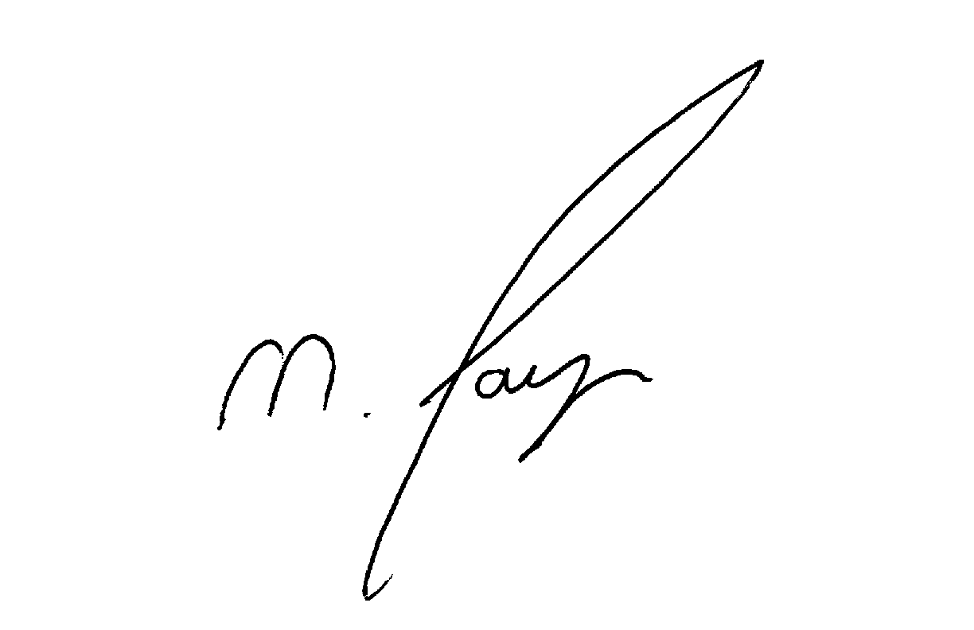  .........................................  Dr Martin Payn,  Conformance Officer  Eurotherm Drives Ltd |  | 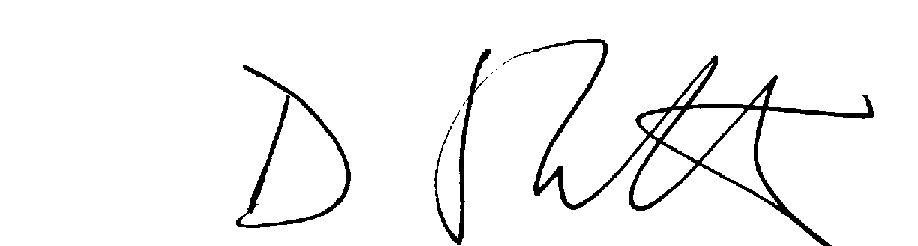  ........................................  Dr Dan Slattery,  Technical Director  Eurotherm Drives Ltd | 12th October 1998  ......................................  Date
EUROTHERM DRIVES LIMITED
NEW COURTWICK LANE, LITTLEHAMPTON, WEST SUSSEX BN17 7PD
TELEPHONE: 01903 721311 FAX: 01903 723938
Registered number: 1159876 England. Registered Office: Leonardslee, Lower Beeding, Horsham, West Sussex RH13 6PP
© 1998 EUROTHERM DRIVES LIMITED
File Name: P:\PRODUCTS\CE\SAFETY\PRODUCTS\584S8_10\LVD\PRODFILE\C_389955.955
ISS: |  | DATE |  | DRN: | MP | DRAWING NUMBER: |  | HK389955C955
 |  |  |  | CHKD: | DS | TITLE:
 | B |  | 12.10.98 |  |  |  | 584SV (Type 8, 9 &10)  EC Declaration of Conformity for Electrical Safety |  |  | SHT 1  OF  1 SHTS
Issue D 20.02.1995 GA387648C017

Manufacturer’s Declaration
Since the potential hazards are mainly electrical rather than mechanical, the 584SV Inverter does not fall under the machinery directive. However, we do supply a manufacturer’s declaration for when the 585SV Inverter is used (as a component) in machinery.
MANUFACTURER’S DECLARATION
The following Electronic Products
584SV (Type 8, 9 & 10)
are components to be incorporated into machinery and may not be operated alone.
The complete machinery or installation using this equipment may only be put into service when the safety considerations of the Directive 89/392/EEC are fully adhered to.
Particular reference should be made to
EN60204-1 ( Safety of Machinery - Electrical Equipment of Machines).
All instructions, warnings and safety information of the Product Manual and Addendum must be adhered to.
.........................................  Dr Martin Payn,  Conformance Officer  Eurotherm Drives Ltd |  | ........................................  Dr Dan Slattery,  Technical Director  Eurotherm Drives Ltd | 4th March 1998  ......................................  Date
EUROTHERM DRIVES LIMITED
NEW COURTWICK LANE, LITTLEHAMPTON, WEST SUSSEX BN17 7PD
TELEPHONE: 01903 721311 FAX: 01903 723938
Registered number: 1159876 England. Registered Office: Leonardslee, Lower Beeding, Horsham, West Sussex RH13 6PP
© 1998 EUROTHERM DRIVES LIMITED
File Name: P:\PRODUCTS\CE\SAFETY\PRODUCTS\584S8_10\LVD\PRODFILE\B_389955.918
ISS: |  | DATE |  | DRN: | MPC | DRAWING NUMBER: |  | HK389955C918
 |  |  |  | CHKD: | MP | TITLE:
 | A  B |  | 06.12.96  04.03.98 |  |  |  | 584SV Type 8/9/10  Machinery Directive |  |  | SHT 1  OF  1 SHTS
Issue D 20.02.1995 GA387648C017

